AP World History
Summer Assignment

This summer you are to prepare to take AP World History by completing the following assignment:

- Study the AP World History regions. This map can be found at
https://secure-media.collegeboard.org/digitalServices/pdf/ap/ap-world-history-course-and-exam-description.pdf (page 33). It is also linked on my website.
Be prepared to be assessed on the regions at the beginning of the school year.
Be familiar with the regions and which countries lay within them.

- Read the book The History of the World in 6 Glasses by Tom Standage. This book can be found at Amazon.com and other bookstores for less than $8.

- Complete the summary assignment on pages 3-4 of this packet.

- Complete the map activity on page 4 in this packet. You will need a blank world map.

- It is highly recommended that you buy an AP Exam Test preparation book. Some suggestions would be Barron’s AP World History, Kaplan AP World History or 5 Steps to a 5. Peruse the books and find the one you like best. You may also look at the linked file “AP Review Books Pros and Cons List” that I have on my website, https://caitlintrippclasses.weebly.com

Due Date: The completed assignment is due on our first day of class. Be prepared to take the map assessment the same day.

Please note: This class is not for the faint of heart or weak of discipline. I treat it like a college course in terms of rigor (though we do a lot more fun, hands on activities than a college course), and you will read at least a chapter of a college-level text per week, with a reading guide or quiz on each chapter. Over the course of each semester, we typically have around 35-40 grades put in, which averages to something in the ball park of 2 or 3 assignments or grades per week (this does include the chapter reading guides). I structure my tests like the AP exam, with rigorous questions and materials. I will provide tutoring hours, study guides, and other support structures, but if you are simply not ready to take on the work load itself, think carefully before taking on this course. Speak to other students who have taken it. I will do my all to help you have fun and dig deep, but if you are not organized or disciplined you will struggle with this course.

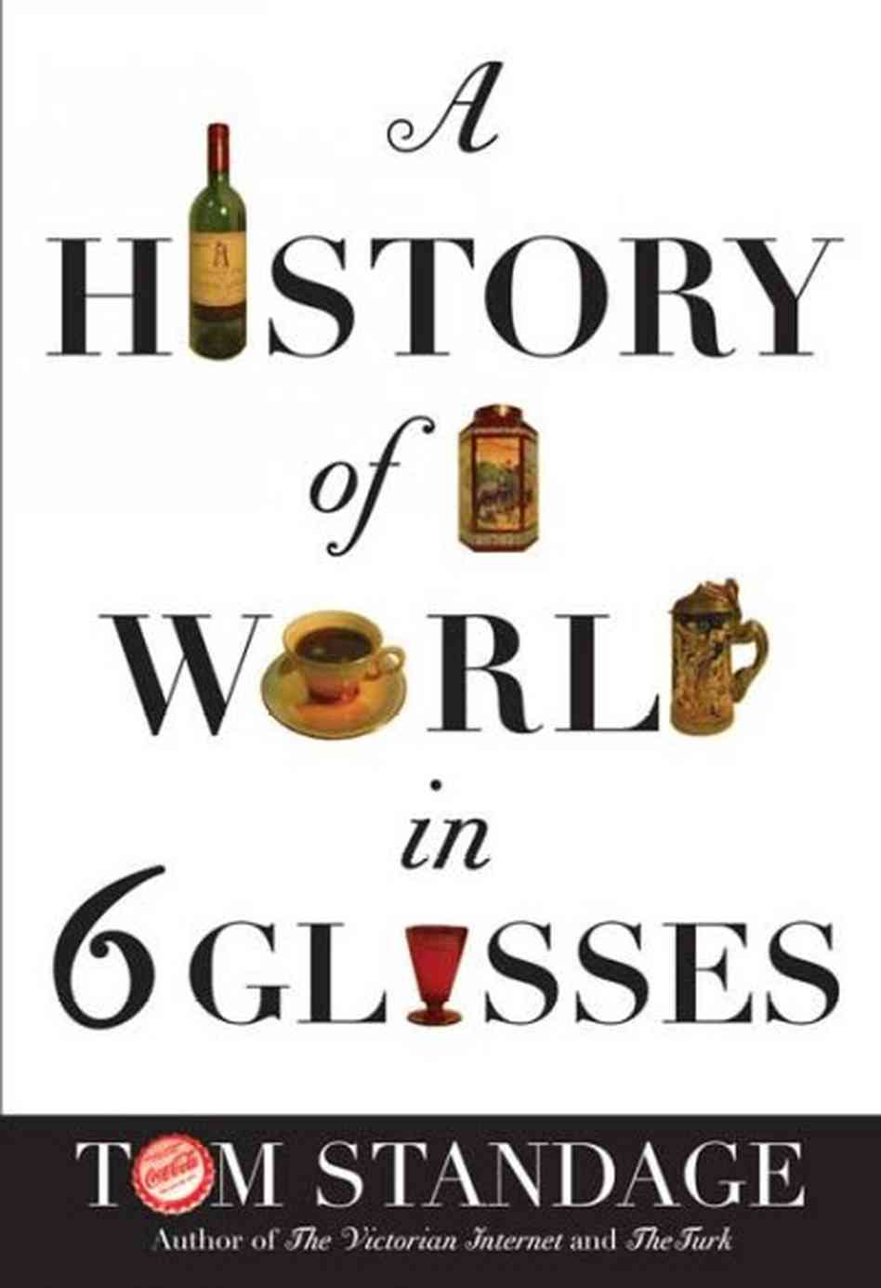
A HISTORY OF THE WORLD IN 6 GLASSES by Tom Standage (2005)
The particular book you have been assigned to read is one that provides an excellent and thought provoking look at world history through the humble beverage. What we drink is something most people take for granted, not giving their potables a second thought. As you will learn throughout this class; everything, from what we drink to the clothes we wear, from the technology we use; to the religion we practice; everything has an interrelated history.

About the author: Tom Standage is digital editor at The Economist, overseeing the magazine's website, Economist.com, and its smartphone, tablet and e-reader editions. Before that he was business affairs editor, running the back half of the magazine, and he previously served as business editor, technology editor and science correspondent. Tom is also the author of five history books, including "An Edible History of Humanity" (2009), "A History of the World in Six Glasses" (2005), a New York Times bestseller, and "The Victorian Internet" (1998), described by the Wall Street Journal as a "dot-com cult classic". He writes the video-game column for Intelligent Life, The Economist's lifestyle magazine, is a regular commentator on BBC radio, and has written for other publications including the Guardian, the Daily Telegraph, the New York Times and Wired. He holds a degree in engineering and computer science from Oxford University, and is the least musical member of a musical family. He is married and lives in London with his wife and children, and is currently working on his next book, on the prehistory of social media. It is entitled “Writing on the Wall: Social Media - The First 2,000 Years” (scheduled for release on Oct 15, 2013).

Tom Standage starts with a bold hypothesis—that each epoch, from the Stone Age to the present, has had its signature beverage—and takes readers on an extraordinary trip through world history. The Economist's technology editor has the ability to connect the smallest detail to the big picture and a knack for summarizing vast concepts in a few sentences. He explains how, when humans shifted from hunting and gathering to farming, they saved surplus grain, which sometimes fermented into beer. The Greeks took grapes and made wine, later borrowed by the Romans and the Christians. Arabic scientists experimented with distillation and produced spirits, the ideal drink for long voyages of exploration. Coffee also spread quickly from Arabia to Europe, becoming the "intellectual counterpoint to the geographical expansion of the Age of Exploration." European coffee-houses, which functioned as "the Internet of the Age of Reason," facilitated scientific, financial and industrial cross-fertilization. In the British industrial revolution that followed, tea "was the lubricant that kept the factories running smoothly." Finally, the rise of American capitalism is mirrored in the history of Coca-Cola, which started as a more or less handmade medicinal drink but morphed into a mass-produced global commodity over the course of the 20th century. In and around these grand ideas, Standage tucks some wonderful tidbits—on the antibacterial qualities of tea, Mecca's coffee trials in 1511, Visigoth penalties for destroying vineyards—ending with a thought-provoking proposal for the future of humanity. He suspects it may hinge on our ability to facilitate clean supplies of water to an ever-expanding population.

SUMMER ASSIGNMENT RUBRIC

Name:________________________________________________ Date:_____________

Book:___________________________________________________________________

 | Available Points | Points Earned
Do a HAPP-Y analysis over the book as a whole:  Historical Context, Audience, Purpose, Point of View, and Wh(Y) these things matter to your understanding of the text. [See attached visual on map instructions, page 4, for help.] | 0 – 10 points  (10)
Provide a correct MLA citation for the book | 0-2 points  (2)
1 – What is the main idea of the book?  2 – What is the value or limitation of the book?  3 – Is the topic worthy of investigation? Why or why not? | 1 point each  (3)
Identify 30 QUOTES, NOTES, or TERMS of Importance  You must include the page and/or paragraph number  for all 30. Make this in the form of a 2-column CHART, with these in the left column. These are very individual to you but should be quality, not random, and should not all be from one section of the book. There should be a mix of items. Include 5 from each beverage. | 1 point each  (30)
30 RESPONSES – You must respond to your quotes, notes, or terms above (in right column) by either summarizing in your own words, paraphrasing, defining vocabulary, making connections to the real world or prior knowledge, questioning, or personal response. These should be added to your CHART. | 1 point each  (30)
PERSONAL RESPONSE/Conclusion – Provide a personal conclusion after reading the book that is a minimum 5 sentence paragraph about your thoughts.  - Make personal connections between your life experience/beliefs and the content/ideas of this writing, and/or make world connections to current issues, people, events, or your text  - What in the book surprised, impressed, shocked, or challenged you?  - Did you learn anything insightful?  - What unanswered questions are you left with?  - What aspects of the material did you struggle with the most? | 5 points  (5)
MAP – Complete the attached map instructions on a single, blank, world map. This must be on its own page. | 0 – 5 points  (5)
CREATIVE SUMMATION: Create one of the following in a way that is creative and of good quality – it should sum up what you’ve learned from the book as a whole.  Political Cartoon, Public Service Announcement, Artistic Illustrative Statement, Collage, Informational Brochure, Short Essay, Graphic Organizer, etc. | 0 – 15 points  (15)
TOTAL

The History of the World in Six Glasses: Map Activity

You are going to create one dense/detailed map, so be neat and tidy. Create a legend if
you need to use symbols (highly recommended) for cities on the map.
**It will help if you keep a running list of any geographical references made in each chapter WHILE YOU READ.

1. Chapters 1-4: Eurasia
a. Use yellow to shade the entire area that was touched by the use of beer & red for the area touched by wine according to these chapters.
b. Label any geographical reference for these chapters in RED INK. Cities, regions (Fertile Crescent), rivers, mountains, deserts, plateaus, seas, oceans.

2. Chapters 5-6: World
a. Use a pale green to shade the entire area touched by distilled spirits according to these chapters.
b. Label any geographical reference for these chapters in GREEN INK. Cities, regions, rivers, mountains, deserts, plateaus, seas, oceans.

3. Chapters 7-8: Eurasia
a. Use a pale blue to shade the entire area touched by coffee according to these areas.
b. Label any geographical reference for these chapters in BLUE INK. Cities, regions, rivers, mountains, deserts, plateaus, seas, oceans.

4. Chapters 9-10: Eurasia
a. Use a light brown to shade the entire area touched by tea according to these areas.
b. Label any geographical reference for these chapters in BLACK INK. Cities, regions, rivers, mountains, deserts, plateaus, seas, oceans.
Use the HAPP-Y chart on the right to complete the first portion of your summary assignment on page 3.

