The Byzantine Empire through Primary Sources
DOCUMENT 4
What is the official faith of the Byzantine Empire?
_______________________________________________
What do these laws say about the level of tolerance shown to those who don’t practice the official religion?
____________________________________________________________________________________________________________________________________________________________________________________________

DOCUMENT 3
Why does Procopius seem so happy about the Hagia Sophia? Analyze his POV (keep in mind that the Hagia Sophia is built almost 30yrs before he writes his Secret History) What about who he is contributes to what he is saying?
___________________________________________________________________________________________________________________________________________________________________________________________________________________________________________

DOCUMENT 2
What are some of the words Procopius uses to describe Justinian?
______________________________________________________________________________________________
What additional document would you ask for to gain more insight into this document? Why would it help?
__________________________________________________________________________________________________________________________________________________________________________________________________________________________________________________________________________________________

DOCUMENT 1
According to the document what steps did Constantine take to ensure Constantinople was a splendid city that was well protected?
_________________________________________________________________________________________________________________________________________________________________________________________________________________________________________________________________________________________________________________________________________

DOCUMENT 5 & 6

What purposes are served by the law in Doc 5?
_____________________________________________________________________________________________________________________________________________
What does the law in Doc 6 force peasant farmers to do?
______________________________________________________________________________________________
Which types of labor does Byzantine society depend on? (Circle all that apply)
Chattel Slavery (traditional slaves) Indentured Servants
Free Peasant Labor Semi-Free Labor (serfs)

DOCUMENT 7
What unlikely event had to occur in order for the Nika Rebellion to become as serious as it did?
_______________________________________________
Who is primarily responsible for convincing Justinian to not run away?
_______________________________________________
Explain which description of Justinian written by Procopius is supported by this passage? (Secret History or Hagia Sophia)
____________________________________________________________________________________________________________________________________________________________________________________________

The Byzantine Empire through Primary Sources

DOCUMENT 8
What statements are made by the author that allow us to understand the enormous impact of the plague of 542?
_____________________________________________________________________________________________________________________________________________

DOCUMENT 9
What does the document strictly forbid?______________
What other faith we have studied also forbids the depiction of humans and animals in art?
______________________________________________
Under these rules would the depiction of a cross alone be acceptable? Explain.
______________________________________________________________________________________________

DOCUMENT 10
What does the document suggest about the government structure/ political organization of the Byzantine state?
_____________________________________________________________________________________________________________________________________________
What is a theme (themata)? ________________________
_______________________________________________________________________________________________
DOCUMENT 11
Who seems to have more power in the Byzantine Empire? (The Patriarch of the church or the Emperor) explain.
______________________________________________________________________________________________
Using the passage, determine how frequently the emperor got involved in church affairs.
_______________________________________________

DOCUMENT 10 con’t

What is going on outside of the Byzantine Empire which might cause them to place generals in local government positions? (900s CE) (Contextualization)

____________________________________________________________________________________________________________________________________________________________________________________________________________________________________________________________________

DOCUMENTS 2-8
Justinian reigned from 527-565 CE. Summarize the accomplishments and disasters of his period in control
_________________________________________________________________________________________________________________________________________________________________________________________________________________________________________________________________________________________________________________________________________

DOCUMENT 12
What evidence in the document suggests that a split between the two sides of Christianity is coming?
_____________________________________________________________________________________________________________________________________________

DOCUMENT 12
Using evidence, what seems to happen to the Byzantine Empire after the Battle of Manzikert (1071CE)?
______________________________________________________________________________________________
Which group will gain more and more control of the Byzantine as a result of this defeat?
______________________________________________
What other “empire” did this very same group also gain political control of?
_______________________________________________

The Byzantine Empire through Primary Sources

DOCUMENT 1
Sozomen (d. c. 450 CE), Ecclesiastical History, II.3: (City was dedicated in 330CE)
Led by the divine hand, he came to Byzantium in Thrace, beyond Chalcedon in Bithynia, and here he desired to build his city, and render it worthy of the name of Constantine. In obedience to the command of God, he therefore enlarged the city formerly called Byzantium, and surrounded it with high walls; likewise he built splendid dwelling houses; and being aware that the former population was not enough for so great a city, he peopled it with men of rank and their families, whom he summoned from Rome and from other countries. He imposed special taxes to cover the expenses of building and adorning the city, and of supplying the inhabitants with food. He erected all the needed edifices for a great capital---a hippodrome, fountains, porticoes and other beautiful adornments. He named it Constantinople and New Rome---and established it as the Roman capital for all the inhabitants of the North, the South, the East, and the shores of the Mediterranean, from the cities on the Danube and from Epidamnus and the Ionian Gulf to Cyrene and Libya.
He created another Senate which he endowed with the same honors and privileges as that of Rome, and he strove to render the city of his name equal in every way to Rome in Italy; nor were his wishes in vain, for by the favor of God, it became the most populous and wealthy of cities. As this city became the capital of the Empire during the period of religious prosperity, it was not polluted by altars, Grecian temples, nor pagan sacrifices. Constantine also honored this new city of Christ by adorning it with many and splendid houses of prayer, in which the Deity vouchsafed to bless the efforts of the Emperor by giving sensible manifestations of his presence.

DOCUMENT 2

Background on Procopius- Procopius of Caesarea was a prominent late antique scholar from Palaestina Prima. Accompanying the Roman general Belisarius in the wars of the Emperor Justinian, he became the principal historian of the 6th century, writing the Wars of Justinian, the Buildings of Justinian (both of which praised Justinian) and the celebrated Secret History (which outright bashes Justinian). He is commonly held to be the last major historian of the ancient world and came from the old aristocratic class.

Secret History Procopius* -On Justinian from Chapter VII (sometime between 550-560CE)
I think this is as good a time as any to describe the personal appearance of the man. Now in physique he was neither tall nor short, but of average height; not thin, but moderately plump; his face was round, and not bad looking, for he had good color, even when he fasted for two days. To make a long description short, he much resembled Domitian, Vespasian's son....
Now such was Justinian in appearance; but his character was something I could not fully describe. For he was at once villainous and amenable; as people say colloquially, a moron. He was never truthful with anyone, but always guileful in what he said and did, yet easily hoodwinked by any who wanted to deceive him. His nature was an unnatural mixture of folly and wickedness. What in olden times a peripatetic philosopher said was also true of him, that opposite qualities combine in a man as in the mixing of colors. I will try to portray him, however, insofar as I can fathom his complexity. This Emperor, then, was deceitful, devious, false, hypocritical, two-faced, cruel, skilled in dissembling his thought, never moved to tears by either joy or pain, though he could summon them artfully at will when the occasion demanded, a liar always, not only offhand, but in writing, and when he swore sacred oaths to his subjects in their very hearing. Then he would immediately break his agreements and pledges, like the vilest of slaves, whom indeed only the fear of torture drives to confess their perjury. A faithless friend, he was a treacherous enemy, insane for murder and plunder, quarrelsome and revolutionary, easily led to anything, but never willing to listen to good counsel, quick to plan mischief and carry it out, but finding even the hearing of anything good distasteful to his ears.
The Byzantine Empire through Primary Sources

DOCUMENT 3
HAGIA SOPHIA (537CE)- Procopius
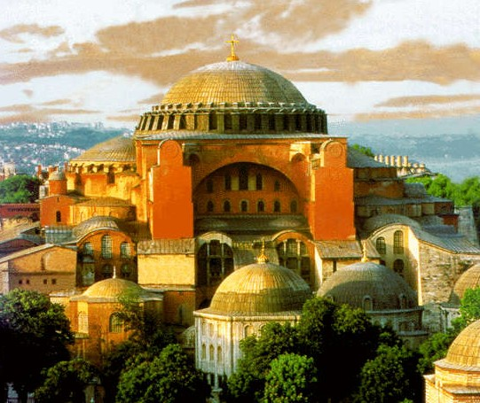
The lowest dregs of the people in Byzantium once assailed the Emperor Justinian in the rebellion called Nika, which I have clearly described in my “History of the Wars.” To prove that it was not merely against the Emperor, but no less against God that they took up arms, they ventured to burn the church of the Christians. (This church the people of Byzantium call Sophia; a name most worthy of God). God permitted them to effect this crime, knowing how great the beauty of this church would be when restored. Thus the church was entirely reduced to ashes; but the Emperor Justinian not long afterwards adorned it in such a fashion, that if anyone has asked the Christians in former times if they wished their church to be destroyed and thus restored, showing them the appearance of the church which we now see, I think it probable that they would have prayed that they might as soon as possible behold their church destroyed, in order that it might be turned into its present form. The Emperor, regardless of expense of all kinds pressed on its restoration and collected together all the workmen from every land. Arthemius of Tralles, by far the most celebrated architect, not only of his own but of all former times, carried out the King’s zealous intentions, organized the labors of the workmen, and prepared the models of the future construction. Associated with him was another architect named Isidorus, a Milesian by birth, a man of intelligence and worthy to carry out the plans of Emperor Justinian. It is indeed, a proof of the esteem with which God regarded the Emperor, that He furnished him with men who would be so useful in effecting his designs, and we are compelled to admire the intelligence of the Emperor, in being able to choose the most suitable of mankind to carry out the noblest of his works.
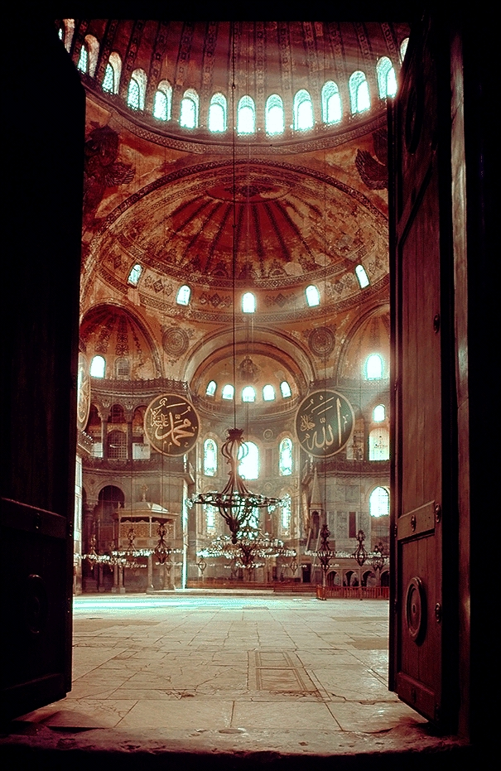

The Byzantine Empire through Primary Sources

DOCUMENT 4

Laws of Justinian (529-534CE)
Besides the Hagia Sophia the other major accomplishment of the Roman’s (of Byzantine Empire) during the reign of Justinian was the Corpus Juris Civilis (Justinian’s Code). Which took centuries of built up Roman law and codified/standardized it for the empire. It was a massive undertaking. Below are a few of the laws which reference the Byzantine attitudes toward Jews.
C.J., 1.5.12 Heretics are all such as do not belong to the Catholic faith including Jews. They are not to hold any office; or follow profession of law. Heavy penalties for connivance with evasion.
C.J., 1,5.13, Orthodox children not to be disinherited by Jewish parents.
C.J, 1.5.17, Complete destruction of Samaritan synagogues ordered.
C.J, 1.3.54, No Jew to possess Christian slaves, or slaves desiring to become Christian.
C.J., 1.10.2, No Jew to own a Christian slave.
C.J., 1.9.2, addressed to the Jews. Sabbath not to be disturbed.

DOCUMENT 5

Codex Justinianus: Return of Fugitive Slaves & Coloni, c. 530CE [Xl.48.xii.]

To strengthen the laws binding slaves and coloni to the soil precautions were taken to prevent landlords employing fugitives and to ensure their return. (*Colonus: Peasant farmer which is tied to the land they work)
Xl.48.xii. We ordain that slaves, or tributaries, or tenet farmers shall remain with their lords. For, when, dismayed by a fear of Ioss, each landowner begins to drive away those who are unknown to him, the will to flight will not be with the slaves; for no one deserts his lord knowing that there is nowhere a refuge for him as a fugitive. But either each one will employ those known to be free men, or will dismiss him who feigns freedom, fearing that he will be liable to those punishments which are ordained by the law. If, therefore, any known fugitive be found anywhere, his detainer shall bring to our fisc twelve pounds of silver, but we decree that to him whose slave he is he shall bring another of the same value in addition to that same fugitive.

DOCUMENT 6

Codex Justinianus: Coloni Bound to the Soil, c. 530CE [Xl.51.i]
*Colonus: Peasant farmer which is tied to the land they work (called serfdom in Medieval Europe)
An earlier law had attached coloni to the soil in provinces of the Empire other than Palestine, but the application of the law was extended to that country by Justinian so that there was apparent uniformity in the matter of the colonate throughout the Empire.
Xl.51.i. Since throughout other provinces which lie under the control of our serene majesty, a law has been passed by the fathers which detains the coloni by a certain law of all time, so that they are not allowed to depart from those places, the fruits of which support them, nor to desert those lands which they once took up for cultivation, and since this is not allowed to the land-holders in Palestine, we ordain, that even throughout Palestine no colonus shall altogether of his own right boast himself a freeman or wanderer, but according to the example of other provinces he shall be attached to the lord of the land so that he may not be able to depart without suffering penalties; moreover, we further decree that full authority of recalling him may be given to the lord of the estate
The Byzantine Empire through Primary Sources

DOCUMENT 7
From History of the Wars, I- Procopius (Nika Rebellion 532CE)
At this time [January 1, 532] an insurrection broke out unexpectedly in Byzantium among the populace, and, contrary to expectation, it proved to be a very serious affair, and ended in great harm to the people and to the senate, as the following account will show.
In every city the population has been divided for a long time past into the Blue and the Green factions; but within comparatively recent times it has come about that, for the sake of these names and the seats which the rival factions occupy in watching the games, they spend their money and abandon their bodies to the most cruel tortures, and even do not think it unworthy to die a most shameful death. And they fight against their opponents knowing not for what end they imperil themselves, but knowing well that, even if they overcome their enemy the fight, the conclusion of the matter for them will be to be carried off straight away to the prison, and finally, after suffering extreme torture, to be destroyed. (Riot broke out at Chariot races against blues and greens and some are being arrested)
At this time the officers of the city administration in Byzantium were leading away to death some of the rioters. But the members of the two factions conspiring together and declaring a truce with each other, seized the prisoners and then straightway entered the prison and released all those who were in confinement there. . . . Fire was applied to the city as if it had fallen under the hand of an enemy. . . . The emperor and his consort, with a few members of the senate shut themselves up in the palace and remained quietly there. Now the watch-word which the populace passed to one another was Nika [i.e., "Conquer"].
The emperor and his court were deliberating as to whether it would be better for them if they remained or if they took to flight in the ships. And many opinions were expressed favoring either course. And the Empress Theodora also spoke to the following effect: "My opinion then is that the present time, above all others, is inopportune for flight, even though it brings safety. . . . For one who has been an emperor it is unendurable to be a fugitive. May I never be separated from this purple, and may I not live that day on which those who meet me shall not address me as mistress. If, now, it is your wish to save yourself, O Emperor, there is no difficulty. For we have much money, and there is the sea, here the boats. However consider whether it will not come about after you have been saved that you would gladly exchange that safety for death. For as for myself, I approve a certain ancient saying that royalty is a good burial-shroud." When the queen had spoken thus, all were filled with boldness, and, turning their thoughts towards resistance, they began to consider how they might be able to defend themselves if any hostile force should come against them. . . .All the hopes of the emperor were centered upon Belisarius and Mundus, of whom the former, Belisarius, had recently returned from the Persian war bringing with him a following which was both powerful and imposing, and in particular he had a great number of spearmen and guards who had received their training in battles and the perils of warfare. . .
(Belisarius leads soldiers against rioters). . There perished among the populace on that day more than thirty thousand. . . . The soldiers killed both [Hypatius and Pompeius] on the following day and threw bodies into the sea. . . . This was the end of the insurrection in Byzantium.

DOCUMENT 8
History of the Wars, II.xxii-xxxiii: (542 CE)
DURING these times there was a pestilence, by which the whole human race came near to being annihilated. Now in the case of all other scourges sent from heaven some explanation of a cause might be given by daring men, such as the many theories propounded by those who are clever in these matters; for they love to conjure up causes which are absolutely incomprehensible to man, and to fabricate outlandish theories of natural philosophy knowing well that they are saying nothing sound but considering it sufficient for them, if they completely deceive by their argument some of those whom they meet and persuade them to their view. But for this calamity it is quite impossible either to express in words or to conceive in thought any explanation, except indeed to refer it to God. For it did not come in a part of the world nor upon certain men, nor did it confine itself to any season of the year, so that from such circumstances it might be possible to find subtle explanations of a cause, but it embraced the entire world, and blighted the lives of all men, though differing from one another in the most marked degree, respecting neither sex nor age
The Byzantine Empire through Primary Sources
DOCUMENT 9
Iconoclastic Council of Constantinople, 754 *Iconoclasm is greek for “Image Breaking”
(it should be noted that Pope Gregory III and the Roman Catholic church supported the use of Icons which created tension between the Eastern and Western parts of the Christian church but was NOT the ultimate cause of the Schism between the two)
Satan misguided men, so that they worshipped the creature instead of the Creator. The Mosaic law and the prophets cooperated to undo this ruin; but in order to save mankind thoroughly, God sent his own Son, who turned us away from error and the worshipping of idols, and taught us the worshipping of God in spirit and in truth. As messengers of his saving doctrine, he left us his Apostles and disciples, and these adorned the Church, his Bride, with his glorious doctrines. This ornament of the Church the holy Fathers and the six Ecumenical Councils have preserved inviolate. But the before-mentioned demi-urgos of wickedness could not endure the sight of this adornment, and gradually brought back idolatry under the appearance of Christianity. As then Christ armed his Apostles against the ancient idolatry with the power of the Holy Spirit, and sent them out into all the world, so has he awakened against the new idolatry his servants our faithful Emperors, and endowed them with the same wisdom of the Holy Spirit. Impelled by the Holy Spirit they could no longer be witnesses of the Church being laid waste by the deception of demons, and summoned the sanctified assembly of the God-beloved bishops, that they might institute at a synod a scriptural examination into the deceitful colouring of the pictures ( omoiwmatwn ) which draws down the spirit of man from the lofty adoration ( latreias ) of God to the low and material adoration ( latreian ) of the creature, and that they, under divine guidance, might express their view on the subject.

DOCUMENT 10

THEOPHANES CONTINUATUS -The Powerful and the Poor
The Reign of Constantine VII (Reigned 913-959)
10. Since the emperor's ears were ringing with the injustices and hardships inflicted on the pitiful and wretched poor (penetes) by the military governors (strategoi), the chief notaries [in charge of provisioning the armed forces] (protonotarioi), the soldiers (stratiotes) and cavalry during his father-in-law Romanos' reign, he sent devout and fair men to ease the great burdens on the wretched poor (ptochoi), which had been levied regardless of circumstance. To the Anatolikon [theme, or province] he sent the magistros Romanos Saronites, to the Opsikion the magistros Romanos Mousele, to the Thrakesion the patrikios Photios, and to the Armeniakon Leo Agelastos. In due course [good men were sent to] the remaining provinces (themata). The men, on the emperor's instruction, gave the poor a small return (mikran anakochen).(1)
Note: This seems to indicate a cash sum returned to the poor, but might simply mean a break from taxation.]

DOCUMENT 11

On Appeals beyond Constantinople, and to the Emperor
"Concerning the Privileges of the Patriarchs", he remarked that "the service of the emperors includes the enlightening and strengthening of both the soul and the body; the dignity of the patriarchs is limited to the benefit of souls and to that only."
“But the appeal is not to be submitted to the ears of the emperor on account of this annoyance. If then someone abandons going to a higher synod, and disputes the proper form of pleas of justification in the rules of appeal, and troubles the emperor about this, not only shall he derive no benefit by as one not being worthy of pardon, but all doors of justification will be fastened against him and he will have no hope of restoration.”
The Byzantine Empire through Primary Sources
DOCUMENT 12
On Constantinople replacing Old Rome
Balsamon, RP3, 146-150
Because it is frequently brought up - when it is necessary to submit the decision of Constantinople to appeal - it seemed necessary to me to add my opinion of this, and to give my reasons...the 4th canon of the Council of Sardica directs that the one who has been condemned has as security two appeals, and that the final judgement be by the pope of Rome...I say that since the decree of St. Constantine, the one given to St. Sylvester, and one which is covered by us in the interpretation of Chap. 1 of Title VIII of the present work, directs that the pope have all the royal powers, and that the Second Ecumenical Council and the Fourth gave the patriarch of Constantinople the privileges of the pope, and decrees with respect to this all honor, from necessity there is not appeal over his decision.

DOCUMENT 13

Michael Psellus (1018-after 1078):Chronographia
* a Byzantine monk, writer, philosopher, politician and historian who from 1055-mid 1070s served as a high ranking advisor to many emperors including Romanos IV Diogenes and Michael VII Doukas
265. Romanus's third campaign against Alp Arslan, the Seljuq ruler, took place in 1071. After varying fortunes the Sultan offered peace, but the emperor refused to accept his terms and a pitched battle was fought at Manzikert (26 August 1071). As a result of treachery on the part of some officers, he was defeated and captured, but not without great gallantry in the face of odds (Scylitzes, 841, p. 699).
269. Psellus conveniently ignores the fact that if Andronicus, the son of John Ducas, had not run away and deliberately spread the rumour that the battle was lost, Romanus might never have been compelled to take such a risk (Scylitzes, 840D, p. 698).
271. The Sultan asked Romanus what he would have done if the Romans had won and the Turkish ruler had been captured. The emperor, without any dissimulation, replied, 'I would have flogged vou to death! ''But I,' said Arslan, 'will not imitate you. I have been told that your Christ teaches gentleness and forgiveness of wrong. He resists the proud and gives grace to the humble.'
284. The truth is that Michael Doukas (emperor starting in 1071 after Diogenes) was a despicable person and some of the blame for his inefficient rule must fall upon Psellus. The young emperor was being trained in logic and philosophy, but the situation of the Empire demanded a soldier, a strong character such as Romanus Diogenes had already proved himself. On all sides the enemies of the Byzantines were meeting with success. Serbia was becoming a dangerous neighbour; the Normans were threatening the west; the Muslims were advancing in the east; the nomad tribes over the Danube were re-commencing their forays; and the Roman armies were discontented and disorganized. In the Byzantine Empire itself there was constant tension too.

