Name:

Civilization Autopsy

Directions: You and your group will be looking into the success and eventual downfall of a civilization. You will be depicting this through an autopsy report.
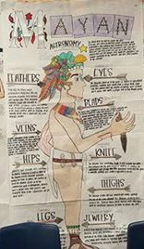

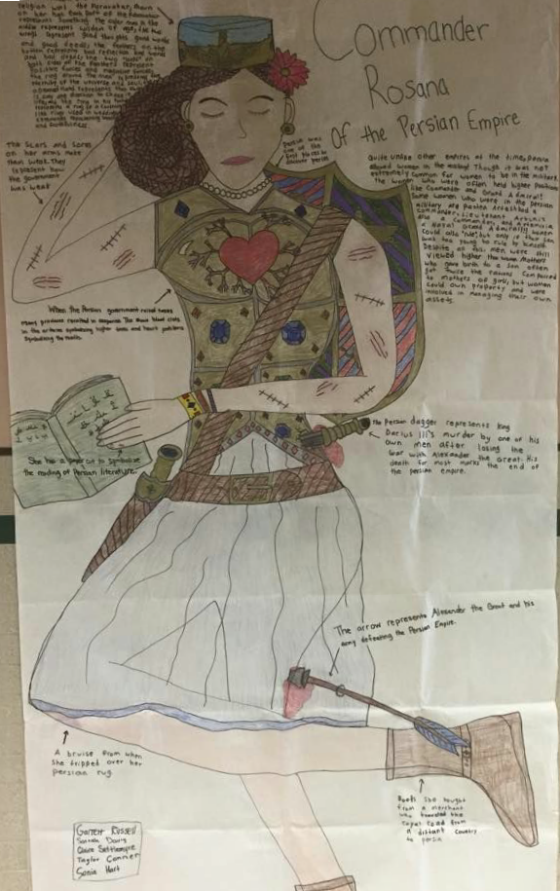

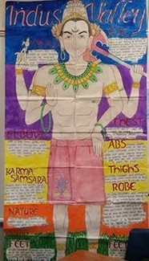

You will need notes on each one of the civilizations, but will only be assigned a poster for one of the following:

Empires:
●
●
●

Part One: Empire Obituary Give me a clear picture of what this civilization was like during healthier times, broken down into the following categories:

● Head: Significant Leaders & Accomplishments
● Hands: Art, Architecture & Tech. Advances
● Legs: Labor Systems
● Spine: Political Structure

● Ribs: Societal Infrastructure
● Heart: Religious Beliefs
● Pen: Literature
● Feet: Trade routes and goods traded

Part Two: Autopsy:
● What led to the decline of this civilization?
● What weakened it?
● What led to their demise?
● Be creative in your delivery.

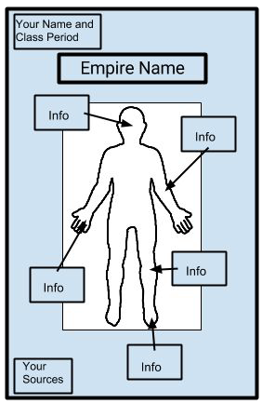
Other Information:
● You need at least three sources of information.
○ One can be your textbook.
○ Cite in APA Format
● Write your empire information in one color.
● Write your autopsy info in a different color.
● Here’s a general idea of what I’m looking for:

Rubric:

 | Exemplary  (100%­90%) | Proficient  (89%­80%) | Partially Proficient  (79%­70%) | Unsatisfactory  (69%­0%)
Content  (0­50pts.)  /50 | ● Content is accurate  ● Content is detailed  ● Content is exemplary  ● Content is presented according to directions | ● Content is accurate  ● Content is adequate  ● Content is comprehensive  ● Content is presented according to directions | ● Content is accurate  ● Content is too basic  ● Content is is missing a few details  ● Content is mostly presented according to directions | ● Content is inaccurate  ● Content lacks necessary detail  ● Content is missing  ● Content isn’t presented as asked
Organization  (0­30pts.)  /20 | ● Info is where it’s supposed to be  ● Poster is neat and easy to read  ● Name/class period are included  ● Sources are cited | ● Info is where it’s supposed to be  ● Poster is adequately legible  ● Name/class period are included  ● Sources are cited | ● Info is on the poster  ● Poster is mostly legible  ● Name/class period are included  ● Sources are cited, incorrectly | ● Info is missing  ● Poster isn’t legible  ● Name and/or class period missing  ● Sources not cited
Creativity/Aesthetics  (0­20pts.)  /15 | ● High level of effort apparent  ● Poster is colorful and creative  ● Organized in a pleasing manner  ● Content is easy to read and flows | ● Effort is apparent  ● Poster is colorful and gets the point across  ● Poster is organized  ● Content is easy to read | ● Effort is so­so  ● Poster lacks color or creativity  ● Poster isn’t organized very well  ● Content is illegible or rushed | ● Effort is embarrassing  ● Poster has no color or creativity  ● Poster has no obvious organization  ● Content is terrible

