Hernán Cortés, marqués del Valle de Oaxaca
Cortés also spelled Cortéz

Synopsis
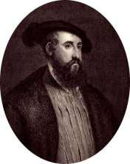
Born around 1485, Hernán Cortés was a Spanish conquistador and explorer who defeated the Aztec empire and claimed Mexico for Spain. He first set sail to the New World at the age of 19. Cortés later joined an expedition to Cuba. In 1518, he set off to explore Mexico. There he strategically aligned some native peoples against others to overthrow them. King Charles I appointed him governor of New Spain in 1522. Cortés died in Spain in 1547.

Early Life

Hernán Cortés, marqués del Valle de Oaxaca, was born around 1485 in Medellín, Spain, and helped advance Spain's position in North America in the 1500s. He came from a lesser noble family in Spain. Some reports indicate that he studied at the University of Salamanca for a time.

In 1504, Cortés left Spain to seek his fortune in New World. He traveled to the island of Santo Domingo, or Hispaniola. Settling in the new town of Azúa, Cortés served as a notary for several years. He joined an expedition of Cuba led by Diego Velázquez in 1511. There, Cortés

worked in the civil government and served as the mayor of Santiago for a time.

Conquered the Aztecs

In 1518, Cortés was to command his own expedition to Mexico, but Velázquez canceled it. Cortés ignored the order and set sail for Mexico with more than 500 men and 11 ships that fall. In February 1519, the expedition reached the Mexican coast.

Cortés became allies with some of the native peoples he encountered, but with others he used deadly force to conquer Mexico. He fought Tlaxacan and Cholula warriors and then set his sights on taking over the Aztec empire. He marched to Tenochtitlán, the Aztec capital and home to ruler Montezuma II. Cortés took Montezuma hostage and his soldiers raided the city. Cortés left the city after learning that Spanish troops were coming to arrest him for disobeying orders.

After facing off against Spanish forces, Cortés returned to Tenochtitlán to find a rebellion in progress. The Aztecs eventually drove the Spanish from the city, but Cortés returned again to defeat them and take the city in 1521. King Charles I of Spain (also known as Holy Roman Emperor Charles V) appointed him the governor of New Spain the following year.
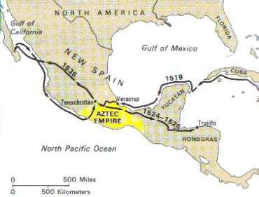
Later Years

After his victory over the Aztecs, Cortés faced challenges to his authority and position. He traveled to Honduras in 1524 to stop a rebellion against him in the area. Back in Mexico, Cortés found himself removed from power. He traveled to Spain to plead his case to the king, but he was not reappointed to his governorship.

In 1540, Cortés retired to Spain. He spent much of his later years seeking recognition for his achievements and support from the Spanish royal court. Cortés died in Spain in 1547

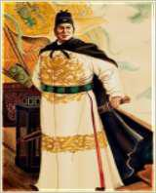
Zheng He

Wade-Giles romanization Cheng Ho, original name Ma Sanbao, later Ma He(born c. 1371, Kunyang [in present-day Jinning county], Yunnan province, China—died 1433, Calicut [now Kozhikode], India), admiraland diplomat who helped to extend Chinese maritime and commercial influence throughout the regions bordering the Indian Ocean.

Zheng He was the son of a ḥājjī, a Muslim who had made the pilgrimage to Mecca. His family claimed descent from an early Mongol governor of Yunnan province in southwestern China as well as from King Muḥammad of Bukhara. The family name Ma was derived from the Chinese rendition of Muḥammad. In 1381, when he was about 10 years old, Yunnan, the last Mongol hold in China, was reconquered by Chinese forces led by generals of the newly established Ming dynasty. The young Ma Sanbao (later Ma He), as he was then known, was among the boys who were captured, castrated, and sent into the

army as orderlies. By 1390, when these troops were placed under the command of the prince of Yan, Ma He had distinguished himself as a junior officer, skilled in war and diplomacy; he also made influential friends at court. In 1400 the prince of Yan revolted against his nephew, the Jianwen emperor, taking the throne in 1402 as the Yongle emperor. Under the Yongle administration (1402–24), the war-devastated economy of China was soon restored. The Ming court then sought to display its naval power to bring the maritime states of South and Southeast Asia in line.

For 300 years the Chinese had been extending their power out to sea. An extensive seaborne commerce had developed to meet the taste of the Chinese for spices and aromatics and the need for raw industrial materials. Chinese travelers abroad, as well as Indian and Muslim visitors, widened the geographic horizon of the Chinese. Technological developments in shipbuilding and in the arts of seafaring reached new heights by the beginning of the Ming.

The emperor having conferred on Ma He, who had become a court eunuch of great influence, the surname Zheng, he was henceforth known as Zheng He. Selected by the emperor to be commander in chief of the missions to the “Western Oceans,” he first set sail in 1405, commanding 62 ships and 27,800 men. The fleet visited Champa (now in southern Vietnam), Siam (Thailand), Malacca (Melaka), and Java; then through the Indian Ocean to Calicut (Kozhikode) and Ceylon (Sri Lanka). Zheng He returned to China in 1407. On his second voyage, in 1408–09, Zheng He again visited Calicut—stopping as well in Chochin (Kochi) to the south—but encountered treachery from King Alagonakkara of Ceylon. Zheng defeated his forces and took the king back to Nanjing as a captive. In October 1409 Zheng He set out on his third voyage. This time, going beyond the seaports of India, he sailed to Hormuz on the Persian Gulf. On his return in 1411 he touched at Samudra, on the northern tip of Sumatra.

On his fourth voyage Zheng He left China in 1413. After stopping at the principal ports of Asia, he proceeded westward from India to Hormuz. A detachment of the fleet cruised southward down the Arabian coast, visiting Djofar and Aden. A Chinese mission visited Mecca and continued to Egypt. The fleet visited Brava and Malindi and almost reached the Mozambique Channel. On his return to China in 1415, Zheng He brought the envoys of more than 30 states of South and Southeast Asia to pay homage to the Chinese emperor. During Zheng He’s fifth voyage (1417–19), the Ming fleet revisited the Persian Gulf and the east coast of Africa. A sixth voyage was launched in 1421 to take home the foreign emissaries from China. Again he visited Southeast Asia, India, Arabia, and Africa. In 1424 the Yongle emperor died. In the shift of policy his successor, the Hongxi emperor, suspended naval expeditions abroad. Zheng He was appointed garrison commander in Nanjing, with the task of disbanding his troops. Zheng He’s seventh and final voyage left China in the winter of 1431, visiting the states of Southeast Asia, the
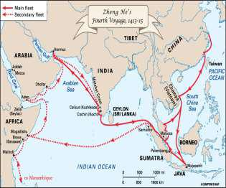
coast of India, the Persian Gulf, the Red Sea, and the east coast of Africa. He died in Calicut in the spring of 1433, and the fleet returned to China that summer.

Zheng He was the best known of the Yongle emperor’s diplomatic agents. Although some historians see no achievement in the naval expeditions other than flattering the emperor’s vanity, these missions did have the effect of extending China’s political sway over maritime Asia for half a century. Admittedly, they did not, like similar voyages of European merchant-adventurers, lead to the establishment of trading empires. Yet, in their wake, Chinese emigration increased, resulting in Chinese colonization in Southeast Asia and the accompanying tributary trade, which lasted to the 19th century.

Pedro Álvares Cabral

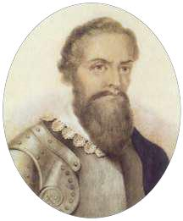
(born 1467/68, Belmonte, Portugal—died 1520, Santarém?), Portuguese navigator who is generally credited as the first European to reach Brazil (April 22, 1500).

The son of Fernão Cabral, a nobleman, and of Isabel de Gouveia, Pedro Cabral was heir to a long tradition of service to the throne. He himself enjoyed the esteem of King Manuel I of Portugal, from whom he received various privileges in 1497; these included a personal allowance, the title of counselor to his highness, and the habit of the military Order of Christ. Three years later the king entrusted him with the command of the second major expedition to India, expressing “the great confidence we have in Pedralvares de Gouveia, nobleman of our household.” Cabral was named admiral in supreme command of 13 ships, which set out from Lisbon on March 9, 1500. He was to follow the route taken earlier by Vasco da Gama, to strengthen commercial ties, and to further the conquest his predecessor had begun.

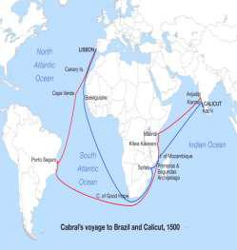

Sailing westward under favorable conditions, on April 22, Cabral sighted the land he named Island of the True Cross. Later renamed Holy Cross by King Manuel, the country ultimately took its modern name, Brazil, from a kind of dyewood, pau-brasil, that is found there.

In accordance with da Gama’s instructions, based on his experiences during the first voyage, Cabral was to sail southwest so as to bypass the becalmed waters of the became known as the “circle around the Portuguese with opportunity to west, which they had previously accordance with the Treaty of Gulf of Guinea. This course, which later Brazil,” had the added advantage of providing reconnoiter along the coast of the lands to the sighted and which belonged to them in Tordesillas (1494).

Cabral is reported to have made a special effort to treat the inhabitants kindly, receiving them on board his caravel. Nonetheless, he took formal possession of the country and dispatched one of his ships to Portugal to inform the king. Henceforth, maps of the region showed Portugal as ruler of a great expanse of land with vaguely defined boundaries that came to serve as a point of call on the long voyage from Europe to the Cape of Good Hope and the Indian Ocean.

After a stay of only 10 days in Brazil, Cabral sailed for India, in a voyage that was plagued by a series of misfortunes. On May 29, while the fleet was rounding the Cape of Good Hope, four ships were lost with all hands aboard. The remaining ships cast anchor on September 13, 1500, at Calicut (Kozhikode), India, where the zamorin (Muslim ruler) welcomed Cabral and allowed him to establish a fortified trading post. Disputes with Muslim traders soon arose, however, and on December 17 a large Muslim force attacked the trading post. Most of the Portuguese defenders were killed before reinforcements could arrive from the Portuguese fleet lying at anchor in the harbor.

Cabral retaliated by bombarding the city and then by capturing 10 Muslim vessels and executing their crews.

He then sailed for the Indian port of Cochin (now Kochi), farther south, where he was affably received and permitted to trade for precious spices, with which he loaded his six remaining ships. Cabral also made port at Carangolos and Cananor (Cannanore; now Kannur) on the same coast, completed his cargo, and on January 16, 1501, began the return voyage to Portugal. On his way, however, two ships foundered, and it was with only four vessels that Cabral finally reached the mouth of the Tagus River in Portugal on June 23, 1501. King Manuel was pleased at the outcome of the undertaking, in spite of the misfortunes that had beset it. He is said to have at first favored making Cabral head of a new and more powerful expedition, but in the end it was Vasco da Gama and not Cabral who was appointed to that command. Accounts differ as to the reason for the king’s change of heart. One chronicler attributes it to disagreement over division of authority within the new fleet; another offers the explanation that da Gama opposed the appointment of Cabral on the grounds that da Gama himself already held the title of admiral of all the fleets that might leave Portugal for India and that the disasters of Cabral’s expedition should disqualify him for the new mission. Whatever the true explanation, Cabral held no further position of authority at the Portuguese court. He retired to his estate in the Beira Baixa province of Portugal and spent his remaining years there. His tomb at Santarém as identified in 1848 by the Brazilian historian Francisco Adolfo Varnhagen.
In 1968, the year that marked the fifth centenary of the birth of Cabral, Brazil and Portugal honored the memory of the “admiral of the fleet” in joint festivities. Both Rio de Janeiro and Lisbon have erected monuments in his honor.

Vasco da Gama
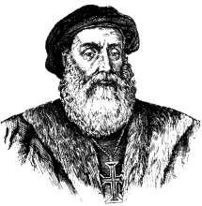
VASCO DA GAMA’S EARLY LIFE AND FIRST VOYAGE TO INDIA

Born circa 1460, Vasco da Gama was the son of a minor nobleman who commanded the fortress at Sines, located on the coast of the Alentejo province in southwestern Portugal. Little else is known about his early life, but in 1492 King John II sent da Gama to the port city of Setubal (south of Lisbon) and to the Algarve region to seize French ships in retaliation for French attacks on Portuguese shipping interests.

Did You Know?

By the time Vasco da Gama returned from his first voyage to India in 1499, he had spent more than two years away from home, including 300 days at sea, and had traveled some 24,000 miles.

Only 54 of his original crew of 170 men returned with him; the majority (including da Gama's brother Paolo) had died of illnesses such as scurvy.

In 1497, John’s successor, King Manuel I (crowned in 1495), chose da Gama to lead a Portuguese fleet to India in search of a maritime route from Western Europe to the East. At the time, the Muslims held a monopoly of trade with India and other Eastern nations, thanks to their geographical position. Da Gama sailed from Lisbon that July with four vessels, traveling south along the coast of Africa before veering far off into the southern Atlantic in order to avoid unfavorable currents. The fleet was finally able to round the Cape of Good

Hope at Africa’s southern tip in late November, and headed north along Africa’s eastern coast, making stops at what is now Mozambique, Mombasa and Malindi (both now in Kenya). With the help of a local navigator, da Gama was able to cross the Indian Ocean and reach the coast of India at Calicut (now Kozhikode) in May 1498.

RELATIONS WITH LOCAL POPULATION & RIVAL TRADERS

Though the local Hindu population of Calicut initially welcomed the arrival of the Portuguese sailors (who mistook them for Christians), tensions quickly flared after da Gama offered their ruler a collection of relatively cheap goods as an arrival gift. This conflict, along with hostility from Muslim traders, led Da Gama to leave without concluding a treaty and return to Portugal. A much larger fleet, commanded by Pedro Alvares

Cabral, was dispatched to capitalize on da Gama’s discoveries and secure a trading post at Calicut.

After Muslim traders killed 50 of his men, Cabral retaliated by burning 10 Muslim cargo vessels and killing the nearly 600 sailors aboard. He then moved on to Cochin, where he established the first Portuguese trading post in India. In 1502, King Manuel put da Gama in charge of another Indian expedition, which sailed that February.

On this voyage, da Gama attacked Arab shipping interests in the region and used force to reach an agreement with Calicut’s ruler. For these brutal demonstrations of power, da Gama was vilified throughout India and the region. Upon his return to Portugal, by contrast, he was richly rewarded for another successful voyage.
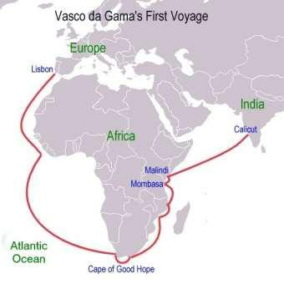
DA GAMA’S LATER LIFE AND LAST VOYAGE TO INDIA

Da Gama had married a well-born woman sometime after returning from his first voyage to India; the couple would have six sons. For the next 20 years, da Gama continued to advise the Portuguese ruler on Indian affairs, but he was not sent back to the region until 1524, when King John III appointed him as Portuguese viceroy in India.

Da Gama arrived in Goa with the task of combating the growing corruption that had tainted the Portuguese government in India. He soon fell ill, and in December 1524 he died in Cochin. His body was later taken back to Portugal for burial there.

Vasco Núñez de Balboa

The 16th-century Spanish conquistador and explorer Vasco Núñez de Balboa (1475-1519) helped establish the first stable settlement on the South American continent at Darién, on the coast of the Isthmus of Panama. In 1513, while leading an expedition in search of gold, he sighted the Pacific Ocean. Balboa claimed the ocean and all of its shores for Spain, opening the way for later

Spanish exploration and conquest along the western coast of South America. Balboa’s achievement and ambition posed a threat to Pedro Arias Dávila, the Spanish governor of Darién, who falsely accused him of treason and had him executed in early 1519.
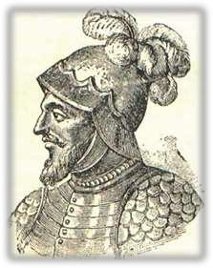
EARLY LIFE AND CAREER OF VASCO NÚÑEZ DE BALBOA

Balboa was born in 1475 in Jerez de los Caballeros, a town in the impoverished Extremadura region of Spain. His father was believed to be a nobleman, but the family was not wealthy; like many of his class, Balboa decided to seek his fortune in the New World. Around 1500, he joined a Spanish expedition that explored the coast of present-day Colombia, then returned to the island of Hispaniola (present-day Haiti and the Dominican Republic) and sought to make his living as a farmer. After falling into debt, he fled his creditors by stowing away on an expedition carrying supplies to the colony of San Sebastian, located on the coast of Urabá (now Colombia), in 1510.

DID YOU KNOW?

The Spanish region of Extremadura, where Vasco Núñez de Balboa was born, was home to many other famous New World conquistadors, including Hernán Cortés, Francisco Pizarro, Hernando de Soto and Francisco de Orellana.

The colony had been largely abandoned by the time they arrived, after local natives killed many of the colonists. At Balboa’s suggestion, they decided to move to the western side of the Gulf of Urabá, on the coast of the Isthmus of Panama, the small strip of land connecting Central and South America. In that region, the local Indians were more peaceful, and the new colony, Darién, would become the first stable Spanish settlement on the South American continent.

BALBOA CATCHES SIGHT OF THE PACIFIC

By 1511, Balboa was acting as interim governor of Darién. Under his authority, the Spaniards dealt harshly with native inhabitants of the region in order to get gold and other riches; from some of these Indians, they learned that a wealthy empire lay to the south (possibly a reference to the Incas). In September 1513, Balboa led an expedition of some 190 Spaniards and a number of Indians southward across the Isthmus of Panama. Late that same month, Balboa climbed a mountain peak and sighted the Pacific Ocean, which the Spaniards called the Mar del Sur (South Sea).

Meanwhile, unbeknownst to Balboa, King Ferdinand II had appointed the elderly nobleman Pedro Arias Dávila (usually called Pedrarias) as the new governor of Darién. As a reward for his explorations, Balboa was named governor of the provinces of Panama and Coiba, but remained under the authority of Pedrarias, who arrived in Darién in mid-1514, soon after Balboa returned.
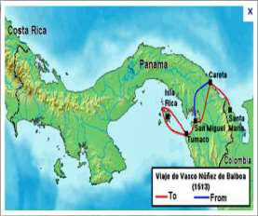
BALBOA’S LATER EXPLORATIONS AND DOWNFALL

Though suspicious of each other, the two men reached a precarious peace, and Pedrarias even betrothed his daughter María (in Spain) to Balboa by proxy. He also reluctantly gave him permission to mount another expedition to explore and conquer the Mar del Sur and its surrounding lands. Balboa began these explorations in 1517-18, after having a fleet of ships painstakingly built and transported in pieces over the mountains to the Pacific.

Meanwhile, Pedrarias’ many enemies had convinced King Ferdinand to send a replacement for him from Spain and order a judicial inquiry into his conduct as leader of Darién. Suspecting Balboa would speak against him, and fearing his influence and popularity, Pedrarias summoned the explorer home and had him arrested and tried for rebellion and high treason, among other charges. In the highly biased trial that ensued, presided over by Pedrarias’ ally Gaspar de Espinosa, Balboa was found guilty and condemned to death. He was beheaded, along with four alleged accomplices, in 1519.

Ferdinand Magellan
QUOTES

“The Church says that the Earth is flat, but I know that it is round. For I have seen the shadow of the earth on the moon and I have more faith in the Shadow than in the Church.”
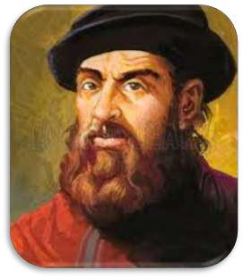
—Ferdinand Magellan

Synopsis

Ferdinand Magellan was born in Portugal circa 1480. As a boy, he studied mapmaking and navigation. By his mid-20s, he was sailing in large fleets and was committed in combat. In 1519, with the support of King Charles V of Spain, Magellan set out to circumnavigate the globe. He assembled a fleet of ships and, despite huge setbacks, his own death included, proved that the world was round.

Early Life

Ferdinand Magellan was born in Portugal, either in the city of Porto or in Sabrosa, circa 1480. His parents were members of the Portuguese nobility, so after their deaths, when he was just 10 years old, Magellan became a page for the queen. Magellan studied at Queen Leonora's School of Pages in Lisbon and spent his days poring over texts on cartography, astronomy, and celestial navigation— subjects that would serve him well in his later pursuits.

Navigator and Explorer

In his mid-20s, Magellan joined a Portuguese fleet that was sailing to East Africa. He soon found himself at the Battle of Diu, in which the Portuguese destroyed Egyptian ships in the Arabian Sea. He also explored Malacca, located

in present-day Malaysia, and participated in the conquest of Malacca's port. It is possible that he sailed as far as the Moluccas, islands in Indonesia, then called the Spice Islands. The Moluccas were the original source of some of the world's most valuable spices, including cloves and nutmeg. The conquest of spice-rich countries was, as a result, a source of much European competition.

While serving in Morocco, Magellan was wounded, and walked the remainder of his life with a limp. After his injury, he was falsely accused of trading illegally with the Moors, and despite all of his service to Portugal, and his many pleas to the king, any further offers of employment were withheld him.

In 1517, Magellan moved to Seville, Spain, to offer his skills to the Spanish court. In the three years following his departure from Portugal, he had religiously studied all of the most recent navigation charts. He had also benefited from the mistakes and discoveries of several other explorers—Christopher Columbus's "discovery" of North America and Vasco Núñez de Balboa's march across the Panamanian isthmus to the Pacific Ocean were just two of the many events that inspired Magellan's bold quest for an all-water passage to farther-flung, spice-rich lands.

Final Years

Magellan devised a plan for circumnavigating the globe, and King Charles V of Spain gave it his blessing. On September 20, 1519, he set out with a fleet of five ships, beautifully named but hardly adequate to sail the distances he proposed. The fleet sailed first to Brazil and then down the coast of South America to Patagonia. There, an attempted mutiny took place, and one of the ships was

wrecked. Despite the setback, the crew continued on with the four remaining vessels.
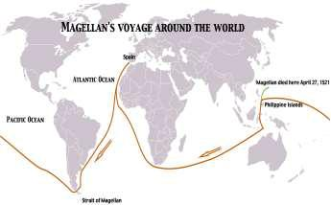
By October 1520, Magellan and his men had entered what is now called the Strait of Magellan. It took them over a month to pass through the strait, during which time the master of one of the ships deserted and sailed back home. In March 1521, the fleet anchored in Guam.

It is a lesser-known fact that Magellan became involved in a local war in the Philippines, where he was killed in battle on April 27, 1521. It's also largely unknown that it was the remaining members of his crew, namely Juan Sebastián del Cano, who actually completed the circumnavigation of the globe. The following year, on September 8, 1522, despite having almost lost their lives in their efforts, the remainder of Magellan's fleet returned to Spain, thus proving that the globe was in fact round.

Francisco Pizarro
QUOTES

“Choose. You may return to the poverty of Panama or cross this line and come with me through infinite dangers but eventual wealth.”
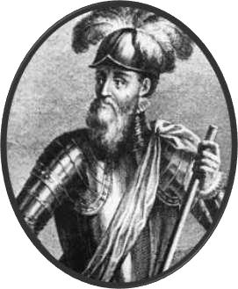
—Francisco Pizarro

Synopsis

Francisco Pizarro was born circa 1476 in Trujillo, Spain. In 1513, he joined Vasco Núñez de Balboa in his march to the "South Sea," during which Balboa discovered the Pacific Ocean. In 1532, Pizarro and his brothers conquered Peru. Three years later, Pizarro founded the nation's new capital, Lima. Pizarro was assassinated on June 26, 1541, in Lima, Peru, by vengeful members of an enemy faction of conquistadors.

Early Years

Conquistador Francisco Pizarro was born, an illegitimate child, circa 1476, in Trujillo, Spain—an area stricken by poverty. His father, Captain Gonzalo Pizarro, was a poor farmer. His mother, Francisca González, was of humble heritage. Pizarro grew up without learning how to read. Instead, he herded his father's pigs.

As young man, Pizarro heard tales of the New World and was seized by a lust for fortune and adventure. In 1510, he accompanied Spanish explorer Alonzo de Ojeda on a voyage to Urabá, Colombia. Although the expedition was unfruitful, Pizarro proved he could be relied on in a bind.

March to the Sea

In 1513, Pizarro joined conquistador Vasco Núñez de Balboa in his march to the "South Sea," across the Isthmus of Panama. During their journey, Balboa and

Pizarro discovered what is now known as the Pacific Ocean, although Balboa allegedly spied it first, and was therefore credited with the ocean's first European discovery.

Ironically, Pizarro later arrested Balboa under the orders of Pedro Arias de Ávila (also known as Pedrarias), Balboa's rival and a known tyrant. Afterward, Pizarro stayed in Panama for a time, where he was awarded an estate, served as mayor of Panama City and amassed a small fortune.

Reconnaissance Voyages

In 1524, Pizarro teamed up with navigator Diego de Almagro and a priest named Fernando de Luque. The first of their reconnaissance voyages went as far as the San Juan River. The next gave Pizarro the chance to explore further south along the coast. In the meantime, Pizarro's chief navigator, Bartolomé Ruiz, forged across the equator and then returned with word of those regions south of the equator.

Conquering Peru

In 1528, Pizarro went back to Spain and managed to procure a commission from Emperor Charles V. Pizarro was to conquer the southern territory and establish a new Spanish province there. In 1532, accompanied by his brothers, Pizarro overthrew the Inca leader Atahualpa and conquered Peru. Three years later, he founded the new capital city of Lima.

Over time, tensions increasingly built up between the conquistadors who had originally conquered Peru and those who arrived later to stake some claim in the new Spanish province. As a result, conquistadors were torn into two factions—one run by Pizarro, and the other by his former associate, Diego Almagro. After taking Cuzco, Almagro engaged Pizarro and his brothers in the Battle of Las Salinas. Upon the Pizarro brothers' victory, in 1538, Hernando Pizarro captured and executed Almagro. On June 26, 1541, in Lima, Peru, members of the defeated party avenged Almagro's death by assassinating Francisco Pizarro.
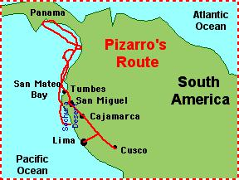
Prince Henry the Navigator
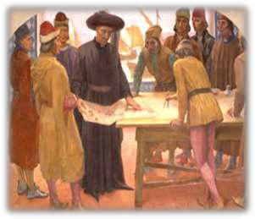
Portugal is a country that has no coast along the Mediterranean Sea so the country's advances in worldwide exploration centuries ago comes at no surprise. However, it was the passion and goals of one man who truly moved Portuguese exploration forward.

Prince Henry was born in 1394 as the third son of King John I (King Joao I) of Portugal. At the age of 21, in 1415, Prince Henry commanded a military force that captured the Muslim outpost of Ceuta, located on the south side of the Strait of Gibraltar.

Three years later, Prince Henry founded his Institute at Sagres on the southwestern-most point of Portugal, Cape Saint Vincent - a place ancient geographers referred to as the western edge of the earth. The institute, best described as a fifteenth century research and development facility, included libraries, an astronomical observatory, ship-building facilities, a chapel, and housing for staff.

The institute was designed to teach navigational techniques to Portuguese sailors, to collect and disseminate geographical

information about the world, to invent and improve navigational and seafaring equipment, to sponsor expeditions, and to spread Christianity around the world. Prince Henry brought together some of the leading geographers, cartographers, astronomers, and mathematicians from throughout Europe to work at the institute.

Although Prince Henry never sailed on any of his expeditions and rarely left Portugal, he became known as Prince Henry the Navigator.

The institute's primary exploration goal was to explore the western coast of Africa to locate a route to Asia. A new type of ship, called a caravel was developed at Sagres. It was fast and was much more maneuverable than prior types of boats and though they were small, they were quite functional. Two of Christopher Columbus' ships, the Nina and the Pinta were caravels (the Santa Maria was a carrack.)

Caravels were dispatched south along the western coast of Africa. Unfortunately, a major obstacle along the African route was Cape Bojador, southeast of the Canary Islands (located in Western Sahara). European sailors were afraid of the cape, for supposedly to its south lay monsters and insurmountable evils.
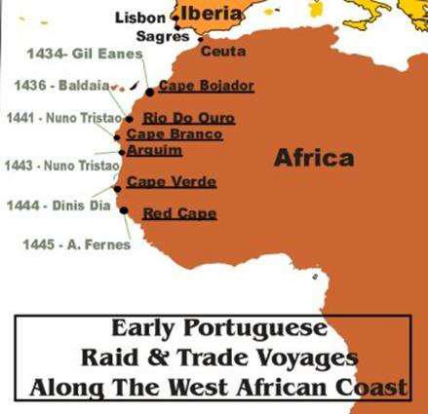
Prince Henry sent fifteen expeditions to navigate south of the cape from 1424 to 1434 but each returned with it's captain giving excuses and apologies for not having passed the dreaded Cape Bojador. Finally, in 1434 Prince Henry sent Captain Gil Eannes (who had previously attempted the Cape Bojador voyage) south; this time, Captain Eannes sailed to the west prior to reaching the cape and then headed eastward once passing the cape. Thus, none of his crew saw the dreadful cape and it had been successfully passed, without catastrophe befalling the ship.

Following the successful navigation south of Cape Bojador, exploration of the African coast continued.

In 1441, Prince Henry's caravels reached Cape Blanc (the cape where Mauritania and Western Sahara meet). In 1444 a dark period of history began when Captain Eannes brought the first boatload of 200 slaves to Portugal. In 1446, Portuguese ships reached the mouth of the Gambia River.

In 1460 Prince Henry the Navigator died but work continued at Sagres under the direction of Henry's nephew, King John II of Portugal. The institute's expeditions continued to venture south and then rounded the Cape of Good Hope and sailed to the east and throughout Asia over the next few decades.

Juan Ponce de Leon

Near present-day St. Augustine, Spanish explorer Juan Ponce de Leon comes ashore on the Florida coast, and claims the territory for the Spanish crown.
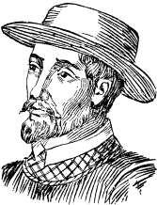
Although other European navigators may have sighted the Florida peninsula before, Ponce de Leon is credited with the first recorded landing and the first detailed exploration of the Florida coast. The Spanish explorer was searching for the “Fountain of Youth,” a fabled water source that was said to bring eternal youth. Ponce de Leon named the peninsula he believed to be an island “La Florida” because his discovery came during the time of the Easter feast, or Pascua Florida.

In 1521, he returned to Florida in an effort to establish a Spanish colony on the island. However, hostile Native Americans attacked his expedition soon after landing, and the party retreated to Cuba, where Ponce de Leon died from a mortal wound suffered during the battle. Successful Spanish colonization of the peninsula finally began at St. Augustine in 1565, and in 1819 the territory passed into U.S. control under the terms of the Florida Purchase Treaty between Spain and the United States.

On the 500th anniversary of his landing in Florida, find out how Ponce de León’s name became inextricably linked with the Fountain of Youth. Tales of sacred, restorative waters existed well before the birth of Spanish conquistador Juan Ponce de León around 1474. Alexander the Great, for example, was said to have come across a healing

“river of paradise” in the fourth century B.C., and similar legends cropped up in such disparate locations as the Canary Islands, Japan, Polynesia and England. During the Middle Ages, some Europeans even believed in the mythical king Prester John, whose kingdom allegedly contained a fountain of youth and a river of gold. “You could trace that up until today,” said Ryan K. Smith, a history professor at Virginia Commonwealth University. “People are still touting miracle cures and miracle waters.”

Spanish sources asserted that the Taino Indians of the Caribbean also spoke of a magic fountain and rejuvenating river that existed somewhere north of Cuba. These rumors conceivably reached the ears of Ponce de León, who is thought to have accompanied Christopher Columbus on his second voyage to the New World in 1493. After helping to brutally crush a Taino rebellion on Hispaniola in 1504, Ponce de León was granted a provincial governorship and hundreds of acres of land, where he used forced Indian labor to raise crops and livestock. In 1508 he received royal permission to colonize San Juan Bautista (now Puerto Rico). He became the island’s first governor a year later, but was soon pushed out in a power struggle with Christopher Columbus’ son Diego.

Having remained in the good graces of King Ferdinand, Ponce de León received a contract in 1512 to explore and settle an island called Bimini. Nowhere in either this contract or a follow-up contract was the Fountain of Youth mentioned. By contrast, specific instructions were given for subjugating the Indians and divvying up any gold found.

Although he may have claimed to know certain “secrets,” Ponce de León likewise never brought up the fountain in his known correspondence with Ferdinand. “What Ponce is really looking for is islands that will become part of what he hopes will be a profitable new governorship,” said J. Michael Francis, a history professor at the University of South Florida St. Petersburg. “From everything I can gather, he was not at all interested or believed that he would find some kind of miraculous spring or lake or body of water.” At least one historian suggests that perhaps Ferdinand, who had recently married a woman 35 years his junior, told Ponce de León to keep his eye out for it

Along the way he purportedly discovered the Gulf Stream, which proved to be the fastest route for sailing back to Europe.

Eight years later, Ponce de León returned to Florida’s southwestern coast in an attempt to establish a colony, but he was mortally wounded by an Indian arrow. Just before leaving, he sent letters to his new king, Charles V, and to the future Pope Adrian VI. Once again, the explorer made no mention of the Fountain of Youth, focusing instead on his desire to settle the land, spread Christianity and discover whether Florida was an island or peninsula. No log of either voyage has survived, and no archaeological footprint has ever been uncovered.
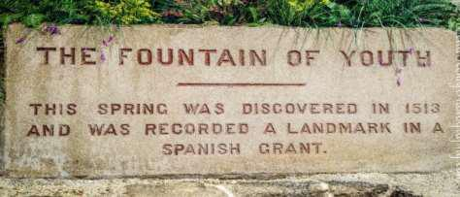
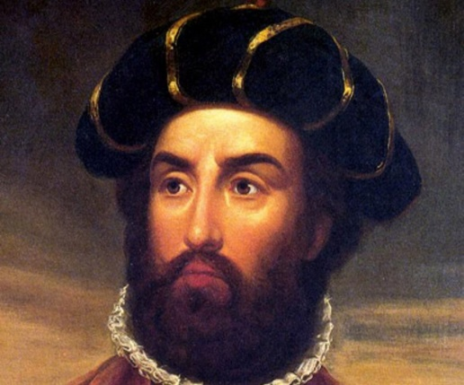
Bartolomeu Dias

In 1488, Portuguese explorer Bartolomeu Dias (c. 1450-1500) became the first European mariner to round the southern tip of Africa, opening the way for a sea route from Europe to Asia. Dias’ ships rounded the perilous Cape of Good Hope and then sailed around Africa’s southernmost point and entered the waters of the Indian Ocean. Portugal and other European nations already had long-established trade ties to Asia, but the arduous overland route had been closed in the 1450s due to the Ottoman Empire’s conquest of the remnants of the Byzantine Empire. A major maritime victory for

Portugal, Dias’ breakthrough opened the door to increased trade with

India and other Asian powers. It also prompted Genoan explorer Christopher Columbus (1451-1506), then living in Portugal, to seek a new royal patron for a mission to establish his own sea route to the Far East.

In August 1487, Dias’ trio of ships departed from the port of

Lisbon, Portugal. Dias followed the route of 15th-century Portuguese explorer Diogo Cão (c. 1450-c. 1486), who had followed the coast of Africa as far as present-day Cape Cross, Namibia. Dias’ cargo included the standard “padrões,” the limestone markers used to stake Portuguese claims on the continent. Padrões were planted at the shoreline and served as guideposts to previous Portuguese explorations of the coast.

Dias’ expedition party included six Africans who had been

brought to Portugal by earlier explorers. Dias dropped off the Africans at different ports along the coastline of Africa with supplies of gold and silver and messages of goodwill from the Portuguese to the indigenous people. The last two Africans were left at a place the Portuguese sailors called Angra do Salto, probably in modern Angola, and the expedition’s supply ship was left there under guard of nine men.

In early January 1488, as Dias’ two ships sailed off the coast of South Africa, storms blew them away from the coast. Dias is thought to have ordered a turn to the south of about 28 degrees, probably because he had prior knowledge of southeasterly winds that would take him around the tip of Africa and keep his ships from being dashed on the notoriously rocky shoreline. João and his predecessors had obtained navigational intelligence, including a 1460 map from Venice that showed the Indian Ocean on the other side of Africa.

Dias’ decision was risky, but it worked. The crew spotted landfall on February 3, 1488, about 300 miles east of present-day Cape of Good Hope. They found a bay they called São Bras (present-day Mossel Bay) and the much warmer waters of the Indian Ocean. From the shoreline, indigenous Khoikhoi pelted Dias’ ships with stones until an arrow fired by either

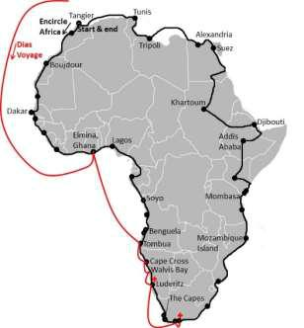
Dias or one of his men felled a tribesman. Dias ventured further along the coastline, but his crew was nervous about the dwindling food supplies and urged him to turn back. As mutiny loomed, Dias appointed a council to decide the matter. The members came to the agreement that they would permit him to sail another three days, then turn back. At Kwaaihoek, in present-day Eastern Cape province, they planted a padrão on March 12, 1488, which marked the easternmost point of Portuguese exploration.

On the journey back, Dias observed the southernmost point of Africa, later called Cabo das Agulhas, or Cape of Needles. Dias named the rocky second cape Cabo das Tormentas (Cape of Storms) for the tempestuous storms and strong Atlantic-Antarctic currents that made ship travel so perilous.

Back in Angra do Salto, Dias and his crew were aghast to find that only three of the nine men left guarding the food ship had survived repeated attacks by locals; a seventh man died on the journey home. In Lisbon, after 15 months at sea and a journey of nearly 16,000 miles, the returning mariners were met by triumphant crowds. In a private meeting with the king, however, Dias was forced to explain his failure to meet up with Paiva and Covilhã. Despite his immense achievement, Dias was never again put in a position of authority. João ordered that henceforth, maps would show the new name for Cabo das Tormentas–Cabo da Boa Esperança, or Cape of Good Hope.

Henry Hudson
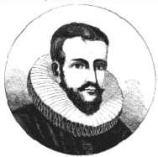
Henry Hudson made his first voyage west from England in 1607, when he was hired to find a shorter route to Asia from Europe through the Arctic Ocean. After twice being turned back by ice, Hudson embarked on a third voyage–this time on behalf of the Dutch East India Company–in 1609. This time, he chose to continue east by a more southern route, drawn by reports of a possible channel across the North

American continent to the Pacific. After navigating the Atlantic coast, Hudson’s ships sailed up a great river (which would later bear his name) but turned back when they determined it was not the channel they sought. On a fourth and final voyage, undertaken for England in 1610-11, Hudson spent months drifting through the vast Hudson Bay and eventually fell victim to a mutiny by his crew, they seized him and his son and set them afloat on a life boat, they were never seen again. Hudson’s discoveries laid the groundwork for Dutch colonization of the Hudson River region, as well as English land claims in Canada.

Though little is known about Hudson’s early life, it seems he studied navigation and earned widespread renown for his skills, as well as his knowledge of Arctic geography. In 1607, the Muscovy Company of London provided Hudson

financial backing based on his claims that he could find an ice-free passage past the North Pole that would provide a shorter route to the rich markets and resources of Asia. Hudson sailed that spring with his son John and 10 companions. They traveled east along the edge of the polar ice pack until they reached the Svalbard archipelago, well north of the Arctic Circle, before hitting ice and being forced to turn back.

While in Amsterdam gathering supplies, Hudson heard reports of two possible channels running across North America to the Pacific. Hudson departed from Holland on the ship Half Moon in April 1609, but when adverse conditions again blocked his route northeast, he ignored his agreement with his employers to return directly and decided to sail to the New World in search of the so-called “northwest passage.”

After landing in Newfoundland, Canada, Hudson’s expedition traveled south along the Atlantic coast and put into the great river discovered by Florentine navigator Giovanni da Verrazano in 1524. They traveled up the river about 150 miles, to what is now Albany, before deciding that it would not lead all the way to the Pacific and turning back. From that point forward, the river would be known as the Hudson. On the return voyage, Hudson docked at Dartmouth, England, where English authorities acted to prevent him and his other English crewmembers from making voyages on behalf of other nations. The ship’s log and records were sent to Holland, where news of Hudson’s discoveries spread quickly.

The British East India Company and the Muscovy Company, along with private sponsors, jointly funded Hudson’s fourth voyage, on which he sought the possible Pacific-bound
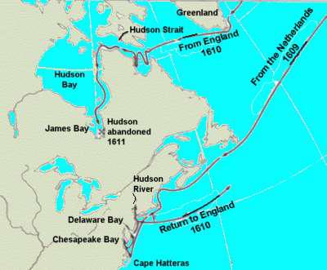
channel identified by Weymouth. Hudson sailed from London in April 1610 in the 55-ton ship Discovery, stopped briefly in Iceland, then continued west. After traversing the coast again, he passed through the inlet Weymouth had described as a potential entry point to a northwest passage. (Now called Hudson Strait, it runs between Baffin Island and northern Quebec.) When the coastline suddenly opened up towards the south, Hudson believed he might have found the Pacific, but he soon realized he had sailed into a gigantic bay, now known as Hudson Bay.

Hudson continued sailing southward along the bay’s eastern coast until he reached its southernmost extremity at James Bay, between northern Ontario and Quebec. While enduring harsh winter conditions with no outlet to the Pacific in sight, some crewmembers grew restless and hostile, suspecting Hudson of hoarding rations to give to his favorites. In June 1611, as the expedition began heading back to England, sailors Henry Green and Robert Juet (who had been demoted as mate) led a mutiny. Seizing Hudson and his son, they cast them adrift on Hudson Bay in a small open lifeboat, along with seven other men who were suffering from scurvy. Hudson was never heard from again.

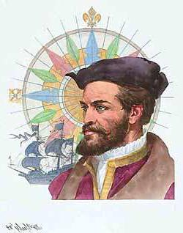
Jacques Cartier
In 1534, France’s King Francis I authorized the navigator Jacques Cartier

(1491-1557) to lead a voyage to the New World in order to seek gold and other riches, as well as a new route to Asia. Cartier’s three expeditions along the St. Lawrence River would later enable France to lay claim to the lands that would become Canada. Born in Saint-Malo, France, Cartier began sailing as a young man. He gained a reputation as a skilled navigator prior to making his three famous voyages to North America.

JACQUES CARTIER’S FIRST NORTH AMERICAN VOYAGE

Cartier was believed to have traveled to Brazil and Newfoundland before 1534. That year, the government of King Francis I commissioned Cartier to lead an expedition to the “northern lands,” as the east coast of North

America was then known. The purpose of the voyage was to find a northern passage to Asia, as well as to collect riches such as gold and spices along the way.

DID YOU KNOW?

In addition to his exploration of the St. Lawrence region, Jacques Cartier is credited with giving Canada its name. He reportedly misused the Iroquois word kanata (meaning village or settlement) to refer to the entire region around what is now Quebec City; it was later extended to the entire country.

Cartier set sail in April 1534 with two ships and 61 men, and arrived 20 days later. During that first expedition, he explored the western coast of Newfoundland and the Gulf of St. Lawrence as far as today’s Anticosti Island, which Cartier called Assomption. He is also credited with the discovery of what is now known as Prince Edward Island.

CARTIER’S SECOND VOYAGE

Cartier returned to make his report of the expedition to King Francis, bringing with him two captured Native Americans from the Gaspé Peninsula. The king sent Cartier back across the Atlantic the following year with three ships and 110 men. With the two captives acting as guides, the explorers headed up the St. Lawrence River as far as Quebec, where they established a base camp.

The following winter wrought havoc on the expedition, with 25 of Cartier’s men dying of scurvy and the entire group incurring the anger of the initially friendly Iroquois population. In the spring, the explorers seized several Iroquois chiefs and traveled back to France. Though he had not been able to explore it himself, Cartier told the king of the Iroquois’ accounts of another great river stretching west, leading to untapped riches and possibly to Asia.

CARTIER’S THIRD AND FINAL VOYAGE

War in Europe stalled plans for another expedition, which finally went forward in 1541. This time, King Francis charged the nobleman Jean-François de La Rocque de Roberval with founding a permanent colony in the northern lands. Cartier sailed a few months ahead of Roberval, and arrived in Quebec in August 1541. After enduring another harsh winter, Cartier decided not to wait for the colonists to arrive, but sailed for France with a quantity of what he thought were gold and diamonds, which had been found near the Quebec camp.
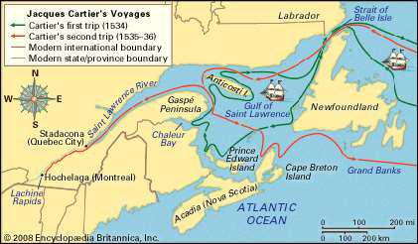
Along the way, Cartier stopped in Newfoundland and encountered Roberval, who ordered Cartier to return with him to Quebec. Rather than obey this command, Cartier sailed away under cover of night. When he arrived back in France, however, the minerals he brought were found to have no value. Cartier received no more royal commissions, and would remain at his estate in Saint-Malo for the rest of his life. Meanwhile, Roberval’s colonists abandoned the idea of a permanent settlement after barely a year, and it would be more than 50 years before France again showed interest in its North American claims.

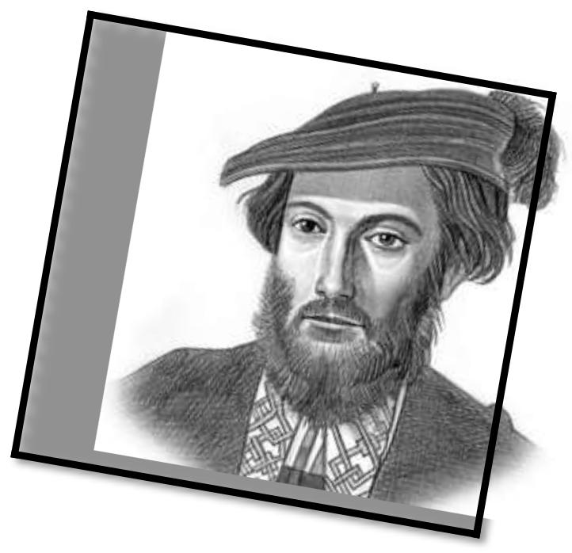
Amerigo Vespucci

Amerigo Vespucci was an Italian-born merchant and explorer who took part in early voyages to the New World on behalf of Spain around the late 15th century. By that time, the Vikings had established settlements in present-day North America as early as 1,000 A.D. and Christopher Columbus had already “discovered” several Caribbean and Central American islands, yet it’s Vespucci’s name that prevailed.

Early accounts of Vespucci’s voyages, now believed to have been forgeries, had quickly spread throughout Europe. In 1507, using these letters as his guide, a German cartographer created a new map, naming the territory now known as South

America in Vespucci’s honor. For the first time, the word “America” was in print.

The first use of the name "America" was in 1507, when a new world map was created based on the explorations of Amerigo Vespucci.

The period during which Vespucci made his voyages falls between 1497 and 1504. Two series of documents on his voyages are extant. The first series consists of a letter in the name of Vespucci dated from Lisbon, Portugal, September 4, 1504, written in Italian, perhaps to the gonfalonier (magistrate of a
medieval Italian republic) Piero Soderini. The second series consists of three private

letters addressed to the Medici. In the first series of documents, four voyages by Vespucci are mentioned; in the second, only two.

The voyage completed by Vespucci between May 1499 and June 1500 as navigator of an expedition of four ships sent from Spain under the command of Alonso de Ojeda is certainly authentic. Since Vespucci took part as navigator, he certainly cannot have been inexperienced; but it does not seem possible that he had made a previous voyage (1497–98) in this area (i.e., around the Gulf of Mexico and the Atlantic coast from Florida to Chesapeake Bay), though this matter remains unresolved.

In the voyage of 1499–1500 Vespucci would seem to have left Ojeda after reaching the coast of what is now Guyana. Turning south, he is believed to have discovered the mouth of the Amazon River and to have gone as far as Cape St. Augustine (latitude about 6° S). On the way back he reached Trinidad, sighted the mouth of the Orinoco River, and then made for Haiti.

Vespucci thought he had sailed along the coast of the extreme easterly peninsula of Asia, where Ptolemy, the geographer, believed the market of Cattigara to be; so he looked for the tip of this peninsula, calling it Cape Cattigara. He supposed that the ships, once past this point, emerged into the seas of southern Asia. As soon as he was back in Spain, he equipped a fresh expedition with the aim of reaching the Indian Ocean, but the Spanish government did not welcome his proposals, and at the end of 1500 Vespucci went into the service of Portugal.

Under Portuguese auspices Vespucci completed a second expedition, which set off from Lisbon on May 13, 1501. After a halt at the Cape Verde Islands, the expedition traveled southwestward and reached the coast of Brazil toward Cape St. Augustine. The remainder of the voyage is disputed, but Vespucci claimed to have continued southward, and he may have sighted (January 1502) Guanabara Bay (Rio de Janeiro’s bay) and sailed as far as the Río de la Plata, making Vespucci the first European to discover that estuary (Juan Díaz de Solís arrived there in 1516). The ships may have journeyed still farther south, along the coast of Patagonia (in present-day southern Argentina). The return route is unknown. Vespucci’s ships anchored at Lisbon on July 22, 1502.
The voyage of 1501–02 is of fundamental importance in the history of geographic discovery in that Vespucci himself, and scholars as well, became convinced that the newly discovered lands were not part of Asia but a “New World.” In 1507 a humanist, Martin Waldseemüller, reprinted the “Four Voyages of Amerigo”, preceded by a pamphlet of his own entitled “Cosmographiae introductio,” and he suggested that the newly discovered world be named “ab Americo Inventore…quasi Americi terram sive Americam” (“from Amerigo the discoverer…as if it were the land of Americus or America”). The suggestion caught on; the extension of the name to North America, however, came later. On the upper part of the map, with the hemisphere comprising the Old World, appears the picture of Ptolemy; on the part of the map with the New World hemisphere is the picture of Vespucci.

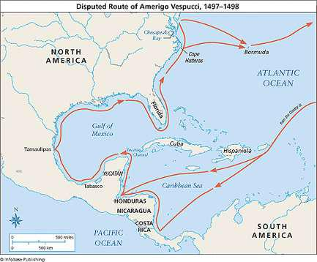
It is uncertain whether Vespucci took part in yet another expedition (1503–04) for the Portuguese government (it is said that he may have been with one under Gonzalo Coelho). In any case, this expedition contributed no fresh knowledge. Although Vespucci subsequently helped to prepare other expeditions, he never again joined one in person. Some scholars have held Vespucci to be a usurper of the merits of others. Yet, despite the possibly deceptive claims made by him or advanced on his behalf, he was a genuine pioneer of Atlantic exploration and a vivid contributor to the early travel literature of the New World.

