Name:__________________________________________

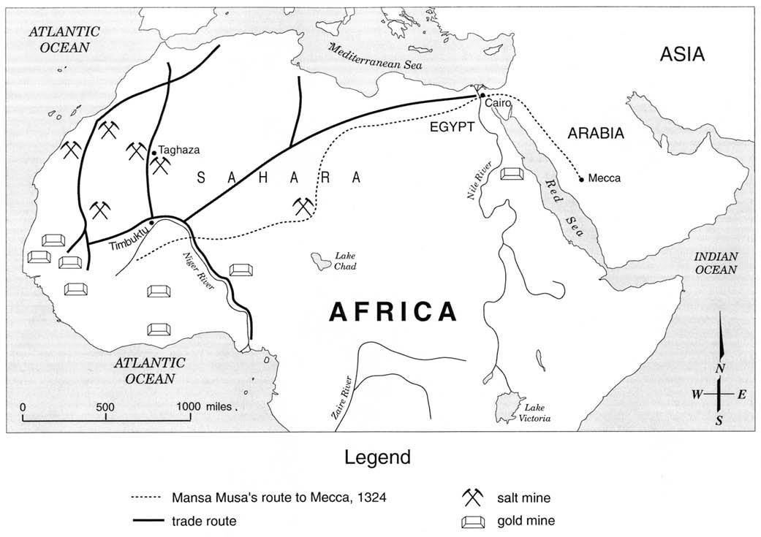
1 Which statement about the trip taken by Emperor Mansa Musa is accurate?
- The trip extended beyond North African trade routes.
- Mansa Musa used the Mediterranean Sea to reach Mecca.
- The route primarily followed major rivers.
- Mansa Musa traveled to Fez on his way to Mecca.

2 Which conclusion about trade is best supported by the information on this map?
- Timbuktu was a center of trade in West Africa.
- The Sahara Desert prevented trade.
- Cairo and Mecca were trading partners.
- West African gold and salt were traded along the Zaire River.

3. How did the use of camels affect trade?

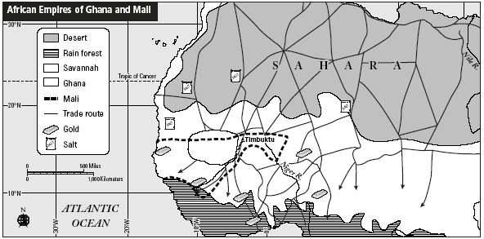
Trans-Saharan Trade
• Salt was mined in the
Sahara Desert and traded
for gold from the south,
as well as crops and
enslaved laborers from
the flat, grassy plains of
the savannah region.
• Around the fourth
century, camels began to
be used in trade caravans.
They could travel long
distances without water,
making the journeys
easier.

Ghana (800–1076)
• Ghana was located where
salt from the north met
the gold and enslaved
Africans from the south.
Ghana controlled the
gold-salt trade.
• Ghana’s king taxed trade
and demanded tribute, or
payment, from nearby
tribes.
• Ghana conquered more
territories. Large trading
cities sprang up, and the
kingdom grew wealthy.

Mali (1235–1400s)
• New sources of gold were
found farther east. As a
result, the trade routes
moved closer to Mali.
• Under the ruler Sundiata,
Mali took control of the
gold-salt trade. Mali grew
wealthy and powerful. It
expanded to include
Ghana’s former territory.
• Mali’s city of Timbuktu,
at the crossroads of the
desert and savannah,
became a center for trade
and learning.

4. Why was Ghana able to control the gold-salt trade?
A It had a strong army that could overpower traders.
B It took the land that Mali once had.
C It owned all of the gold and salt mines.
D It was located at the meeting point for gold and salt traders.

5. What was one result of the shift in trade routes?
A Ghana grew stronger.
B Gold’s value declined.
C Trans-Saharan trade decreased.
D Mali gained control of the gold salt trade.

