Development of the Alphabet: Analyzing a Chart

The alphabet you use every day developed from the alphabet of the ancient Phoenicians. The Phoenicians probably adapted some of their letters from the alphabet of the Aramaeans, who lived nearby. The Aramaeans, in turn, may have adapted their letters form the Egyptian hieroglyphics. The following chart traces the possible development of several letters of the alphabet. An Egyptian hieroglyph and its meaning are given in Column 1. The Aramaean letter adapted from the hieroglyph and its meaning is given in Column 2. The Aramaean name for the letter is given in parentheses. In Columns 3-5, the Phoenician, Greek, and Latin letters are given. Study the chart and answer the questions that follow.
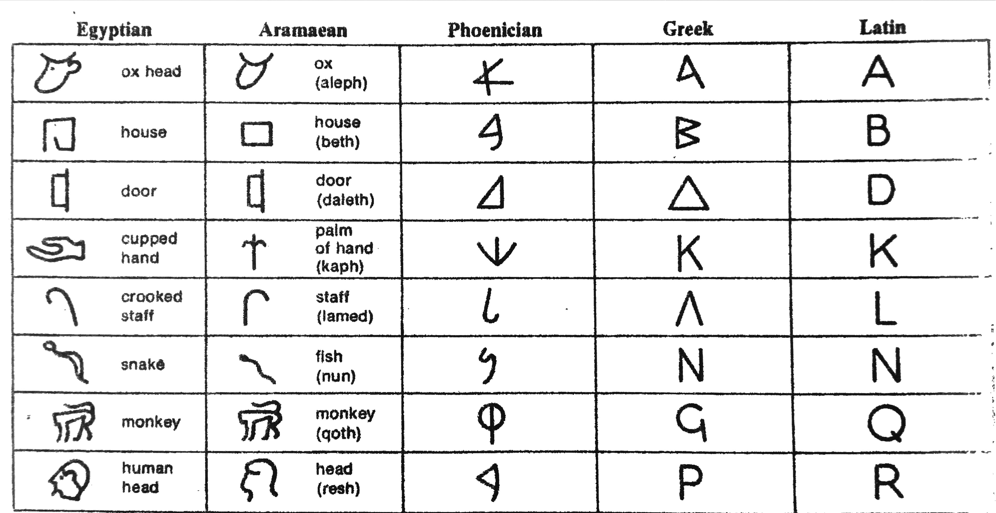
1. (a) From what Egyptian symbol did the letter K develop? __________________________________________________

(b) From what symbol did the letter Q develop? _____________________________________________________________

2. Based on the chart, how do you think the Egyptian symbol for house probably became a symbol for the

B sound?______________________________________________________________________________________________________________

_________________________________________________________________________________________________________________________

3. In what way are the Phoenician letters simpler than the Aramaean letters? ________________________________

_________________________________________________________________________________________________________________________

4. The use of a simplified alphabet made it easer for more people to learn to read and write. Therefore, some historians conclude that the development of an alphabet was an early step toward making society

more democratic. Do you agree? Explain. ________________________________________________________________________

_________________________________________________________________________________________________________________________

