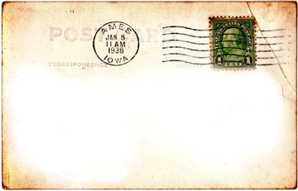
________________________________________________________________________________________________________________________________________________________________________________________________________________________________________________
______________________________________________________________________________
______________________________________________________________________________
________________________________________________________________________________________________________________________________________________________________________________________________________________________________________________

Post Cards
Use your textbook or get a good primary source section of Battuta, Polo, Kempe, or Xuanzang's journeys.
When finished take a “postcard” from up front and create a postcard from one of these travelers to their homes and families.
One side of the postcard should have images reflecting details of what you read and the other should address it to where the postcard is being sent and a quick note that further expresses their wonder of what you have seen. Be intentional to include many relevant details and demonstrate the specific point of view of your traveler.

