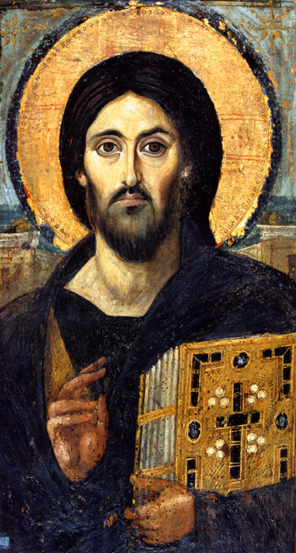
Christ Pantokrator from Sinai
Mid-6th century
St. Catherine's Monastery, Sinai (Israel)
This famous icon of the Savior was a gift of the Emperor Justinian to the Monastery in the 6th century. The Emperor gave the funds for the building and embellishment of the Monastery church which was constructed of local materials. It is most likely that the Emperor commissioned this icon in Constantinople to be sent and his personal contribution to the decoration of the sanctuary.
The icon is painted in a hot wax technique that requires total mastery of the media and a sure hand. Spatulas are used to manipulate the colored waxes which fuse as they cool. Encaustic painting was used across the Roman world and many examples have survived from burials in Roman-era Egypt.

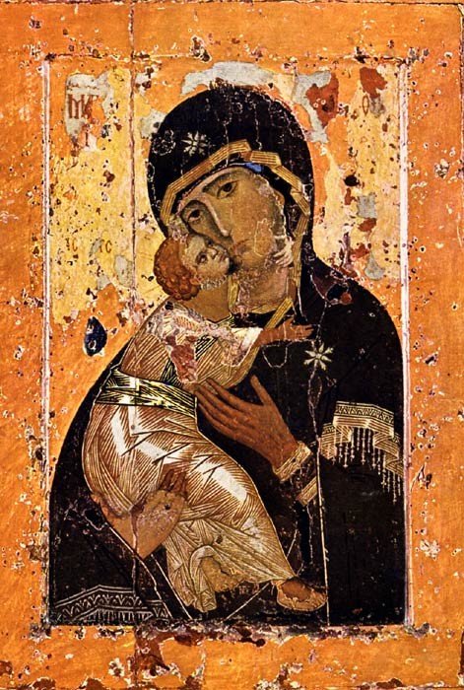
Our Lady of Vladimir
Egg tempera on wood panel
12th century, painted in Constantinople and delivered to Russia.
In 988 Prince Vladimir I of Kiev converted to the Orthodox Christian faith and introduced Christian faith as the official religion of Rus. Church services in Kiev closely followed the Byzantine norms and many icons and liturgical furnishings where brought back for Kiev's growing number of sanctuaries from Byzantium . One of these icons, Our Lady of Vladimir , became widely known and highly revered in Russia.

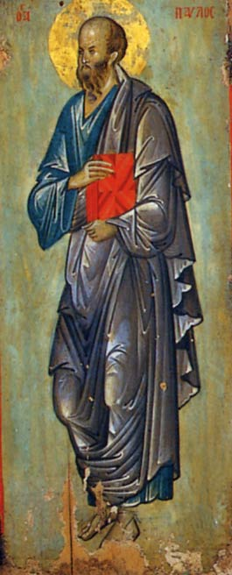
St. Paul
Egg tempera on wood.
14th century, Sinai (Israel)
Holy Monastery of St. Catherine
Not all icons have gold backgrounds. This green color was common both in Russia and Byzantium. There is a stylistic relationship between this icon the mosaic of the Kariye Djami in Istanbul and it has been assigned various date throughout the 14th Century.

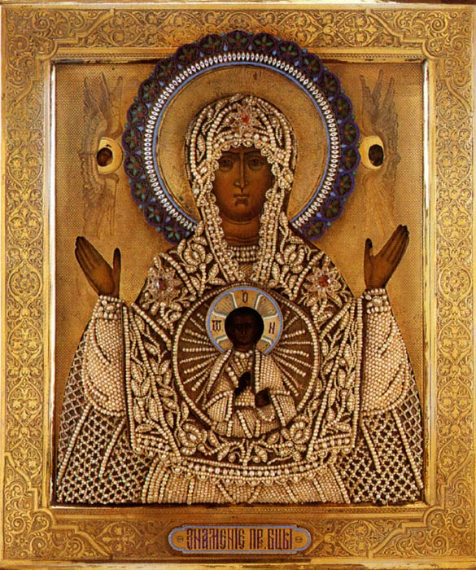
Our Lady of the Sign
Egg tempera on wood, engraved silver-gilt oak, laid with seed pearls and enamel
1882, Russia
Antip Kuzmichev Moscow Private Collection
The Virgin holds her arms outstretched in an attitude of prayer with a medallion of Christ blessing in her breast. The icon is magnificently embellished with a sewn overlay netting of pearls. Three stars on her shoulders and head are set with gemstones. The halo of the Virgin is richly enameled in shades of red and blue with an encircling border of white.
Description of activity: Students will be taught a short lesson about the significance of certain colors in religious Byzantine art (red signifying Jesus’s blood, etc.), the materials used, and basic themes. They will then be asked to analyze these 4 pieces of art for similarities and differences. The pieces are arranged in chronological order so they can analyze for style evolution over time, as well as location.
Question guide for spiral questioning:
- What people are featured in the art?
- What colors are used and what do they signify?
- What materials are used and what does that say about the person who ordered it to be made?
- What similarities do you notice in these pieces?
- What differences do you notice based on evolution over time?
- What differences do you notice based on where the art was made (Byzantium vs. Russia)?
- What conclusions can you draw about the influence of Byzantine art on Russian art?

