Slave Trade HAPP Analysis

- KC 4.2.II – Traditional peasant agriculture increased and changed, plantations expanded, and demand for labor increased. These changes both fed and responded to growing global demand for raw materials and finished products.
- KC4.2.III – As new social and political elites changed, they also restructured new ethnic, racial, and gender hierarchies.

Directions
- Circle the HAPP strategy you are using
- Write your HAPP Statement (2-3 sentences max)
  - Identify and explain they HAPP strategy as it applies to the document
Explain WHY this is important to understanding the document as it relates to the prompt

Prompt: Evaluate the extent to which the Trans-Atlantic Slave Trade transformed the economies and societies of the Atlantic World in the early modern era.

Document #1
Historical Context / Audience / Purpose / POV / Y why is this significant to the argument? ________________________________________________________________________________________________________________________________________________________________________________________________________________________________________________________________________________________________________________________________________________________________________________________________________________________________________________________________________________________________________________________________________________________________________________________________________________________________________________________________________________________________________________________________________________

Document #2
Historical Context / Audience / Purpose / POV / Y why is this significant to the argument? ________________________________________________________________________________________________________________________________________________________________________________________________________________________________________________________________________________________________________________________________________________________________________________________________________________________________________________________________________________________________________________________________________________________________________________________________________________________________________________________________________________________________________________________________________________

Document #3
Historical Context / Audience / Purpose / POV / Y why is this significant to the argument?
________________________________________________________________________________________________________________________________________________________________________________________________________________________________________________________________________________________________________________________________________________________________________________________________________________________________________________________________________________________________________________________________________________________________________________________________________________________________________________________________________________________________________________________________________________

Document #4
Historical Context / Audience / Purpose / POV / Y why is this significant to the argument?
________________________________________________________________________________________________________________________________________________________________________________________________________________________________________________________________________________________________________________________________________________________________________________________________________________________________________________________________________________________________________________________________________________________________________________________________________________________________________________________________________________________________________________________________________________

Document #5
Historical Context / Audience / Purpose / POV / Y why is this significant to the argument?
________________________________________________________________________________________________________________________________________________________________________________________________________________________________________________________________________________________________________________________________________________________________________________________________________________________________________________________________________________________________________________________________________________________________________________________________________________________________________________________________________________________________________________________________________________

Document #6
Historical Context / Audience / Purpose / POV / Y why is this significant to the argument?
________________________________________________________________________________________________________________________________________________________________________________________________________________________________________________________________________________________________________________________________________________________________________________________________________________________________________________________________________________________________________________________________________________________________________________________________________________________________________________________________________________________________________________________________________________

Document #7
Historical Context / Audience / Purpose / POV / Y why is this significant to the argument?
________________________________________________________________________________________________________________________________________________________________________________________________________________________________________________________________________________________________________________________________________________________________________________________________________________________________________________________________________________________________________________________________________________________________________________________________________________________________________________________________________________________________________________________________________________

Document #8
Historical Context / Audience / Purpose / POV / Y why is this significant to the argument?
________________________________________________________________________________________________________________________________________________________________________________________________________________________________________________________________________________________________________________________________________________________________________________________________________________________________________________________________________________________________________________________________________________________________________________________________________________________________________________________________________________________________________________________________________________

Document #9
Historical Context / Audience / Purpose / POV / Y why is this significant to the argument?
________________________________________________________________________________________________________________________________________________________________________________________________________________________________________________________________________________________________________________________________________________________________________________________________________________________________________________________________________________________________________________________________________________________________________________________________________________________________________________________________________________________________________________________________________________

Document #10
Historical Context / Audience / Purpose / POV / Y why is this significant to the argument?
________________________________________________________________________________________________________________________________________________________________________________________________________________________________________________________________________________________________________________________________________________________________________________________________________________________________________________________________________________________________________________________________________________________________________________________________________________________________________________________________________________________________________________________________________________

Write the introduction to a DBQ that includes a thesis and context based on the prompt below:

Prompt: Evaluate the extent to which the TransAtlantic Slave Trade transformed the economies and societies of the Atlantic World in the early modern era.

____________________________________________________________________________________________________________________________________________________________________________________________________________________________________________________________________________________________________________________________________________________________________________________________________________________________________________________________________________________________________________________________________________________________________________________________________________________________________________________________________________________________________________________________________________________________________________________________________________________________________________________________________________________________________________________________________________________________________________________________________________________________________________________________________________________________________________________________________________________________________________________________________________________________________________________________________________________________________________________________________________________________________________________________________________________________________________________________________________________________________________________________________________________________________________________________________________________________________________________________________________________________________________________________________________________________________________________________________________________________________________________________________________________________________________________________________________________________________________________________________________________________________________________________________________________________________________________________________________________________________________________________________________________________________________________________________________________________________________________________________________________________________________________________________________________________________________________________________________________________________________________________________________________________________________________________________________________________________________________________________________________________________________________________________________________________________________________________________________

Document 1

18th Century French Slave Ship

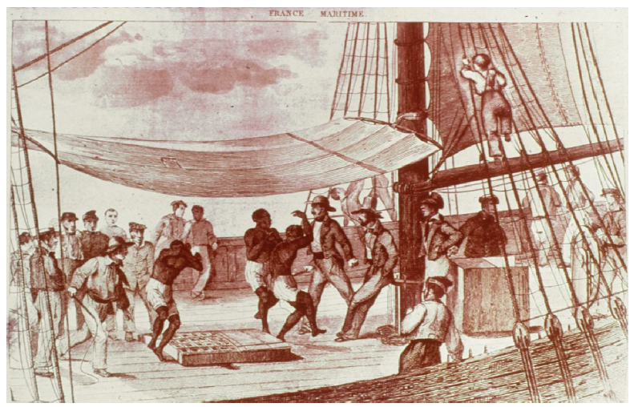

Document 2

Nicholas Owen, Journal of a Slave-Dealer (Agent of a slave trader in Africa in 1758)

“It seems strange that here in the country you’ll find men of ready wit in all things relating to common business, yet if they are questioned concerning a future state, they give up all pretensions to humanity and wander in absurdities as black as their faces. They laugh at one another’s misfortunes and don’t seem to repine their own, given to drunkenness and quarreling, being very cowardly and great boasters, miserably poor in general and live low as to victuals [food supplies], soon provoked to anger and soon made up again if the offender makes an acknowledgement of his crime…”

Document 3

17th century sugar mill, West Indies, probably Dutch-owned island

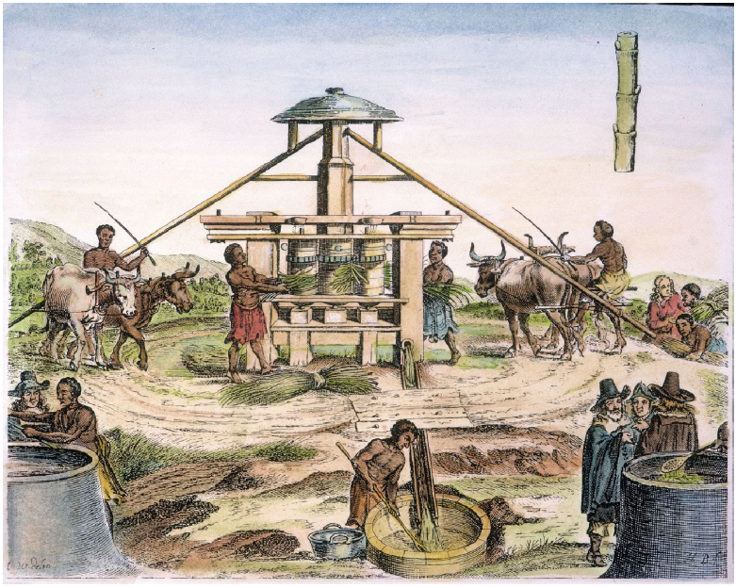

Document 4

Dutch slave trader Johannes de Grevenbroek, 1695

“From us they have learned strife, quarreling, drunkenness, trickery, theft, unbridled desire for what is not one’s own, misdeeds unknown to them before, and the accursed lust for gold.”

Document 5
Map of Slave Trade 1500-1900 (2000s)
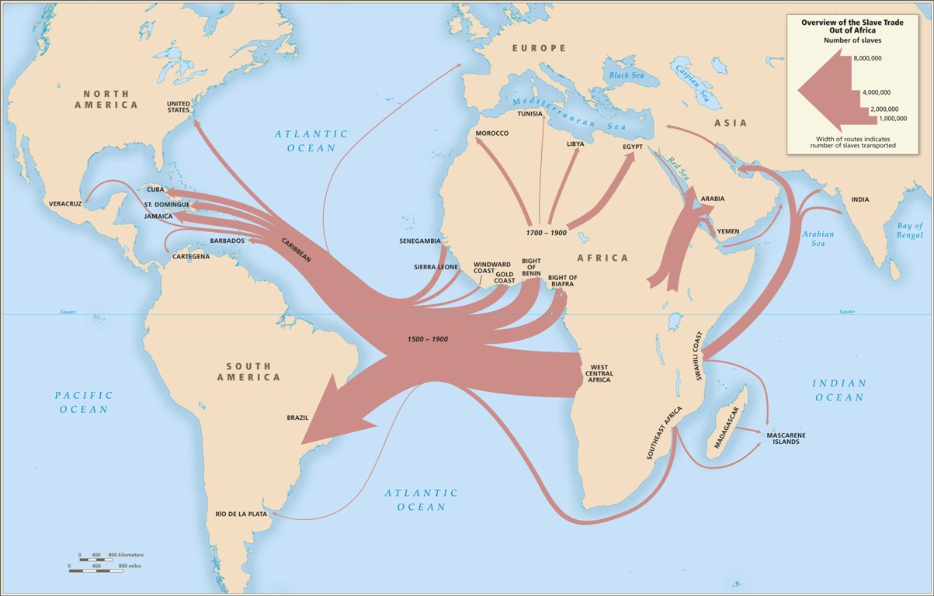

Document 6
Excerpt from a Portuguese Textbook

Slavery was one of the pillars of African societies. The prestige and power of the great African lords was evaluated by the number of slaves one had. The practice of slavery in Africa would facilitate the entry of Europeans into the process. To interpret the slavery trade as a unique form of colonial exploitation is to forget that it was a practice perpetuated by the natives. The slave traders operated directly with the local slave masters. Generally, the advantages to both parties were equal; the African obtained manufactured products from Europe and military help he needed to defend himself against his enemies.

The development of the slave trade became part of the process of settling the American continent. In comparison with Indian slavery, the blacks had a better physical capacity and resisted better to the climate, two important factors to justify the successive waves of slaves that left Africa towards America.
The time between the moment the slaves were bought and when they arrived at port was very dangerous not only for the European traders but for the slaves as well. Revolts and disturbances occurred frequently. Crossing the Atlantic was extremely difficult for slaves. First there was not enough room in the boats. They suffered from heat, thirst, and a lack of hygiene. Even the whites had difficulty with these things.

At the time the European states did not recognize the negative consequences of these massive migrations on the other hand, a new diverse cultural situation originated on the American continent that resulted from the multiplicity of mixed races and cultures. Brazil became the most expressive model of the process carried out by the Portuguese as it melted Indian, white, and black in a complex mix of ethnicities and cultures.

Source: History for Grade Ten, Volume 2, published in Portugal in 1994.
Document 7

Canons at the Cape Coast Castle, former Ghanaian slave castle at Cabo Corso, Ghana

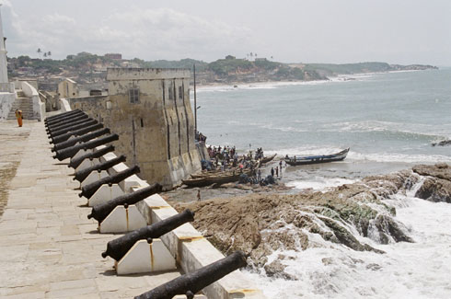

Document 8

The conflict between communities, caused by the external demand for slaves, resulted in conflict within communities. Because of the general environment of uncertainty and insecurity at the time, individuals required weapons, such as iron knives, spears, swords or firearms, to defend themselves. These weapons could be obtained from Europeans in exchange for slaves, which were often obtained through local kidnappings. This further perpetuated the slave trade and the insecurity that it caused, which in turn further increased the need to enslave others to protect oneself. Historians have named this vicious cycle the ‘gun-slave cycle’ or the ‘iron-slave cycle’. The result of this vicious cycle was that communities not only raided other communities for slaves, but also members of a community raided and kidnapped others within the community…

Europeans played a role in promoting political instability. Because those involved in the buying and selling of slaves benefited from a larger supply of slaves, when possible they intervened in the political process to promote internal conflict and instability. Slave merchants and raiders formed strategic alliances with key groups inside villages or states in order to extract slaves. Typically, the alliances were with the younger men of the community who were frustrated by the control of power by the male elders. The consequence of this was increased internal conflict and political instability.

In the end, the consequences of internal conflict and insecurity were increased political instability, and in many cases the collapse of pre-existing forms of government…

Source: “The Long-Term Effects of Africa’s Slave Trades” by Nathan Nunn, October 2006.
Document 9
Josiah Wedgewood, Artist and Abolitionist, 1787
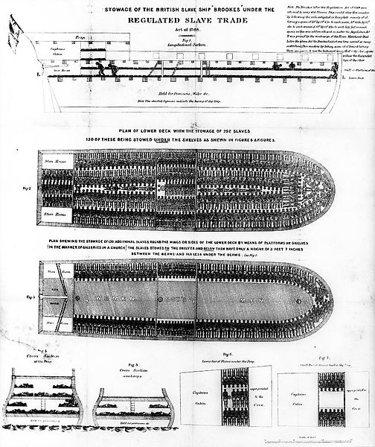
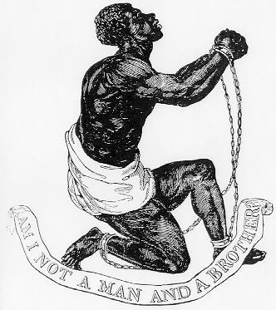

Document 10
Slave Ship Poster 1789

