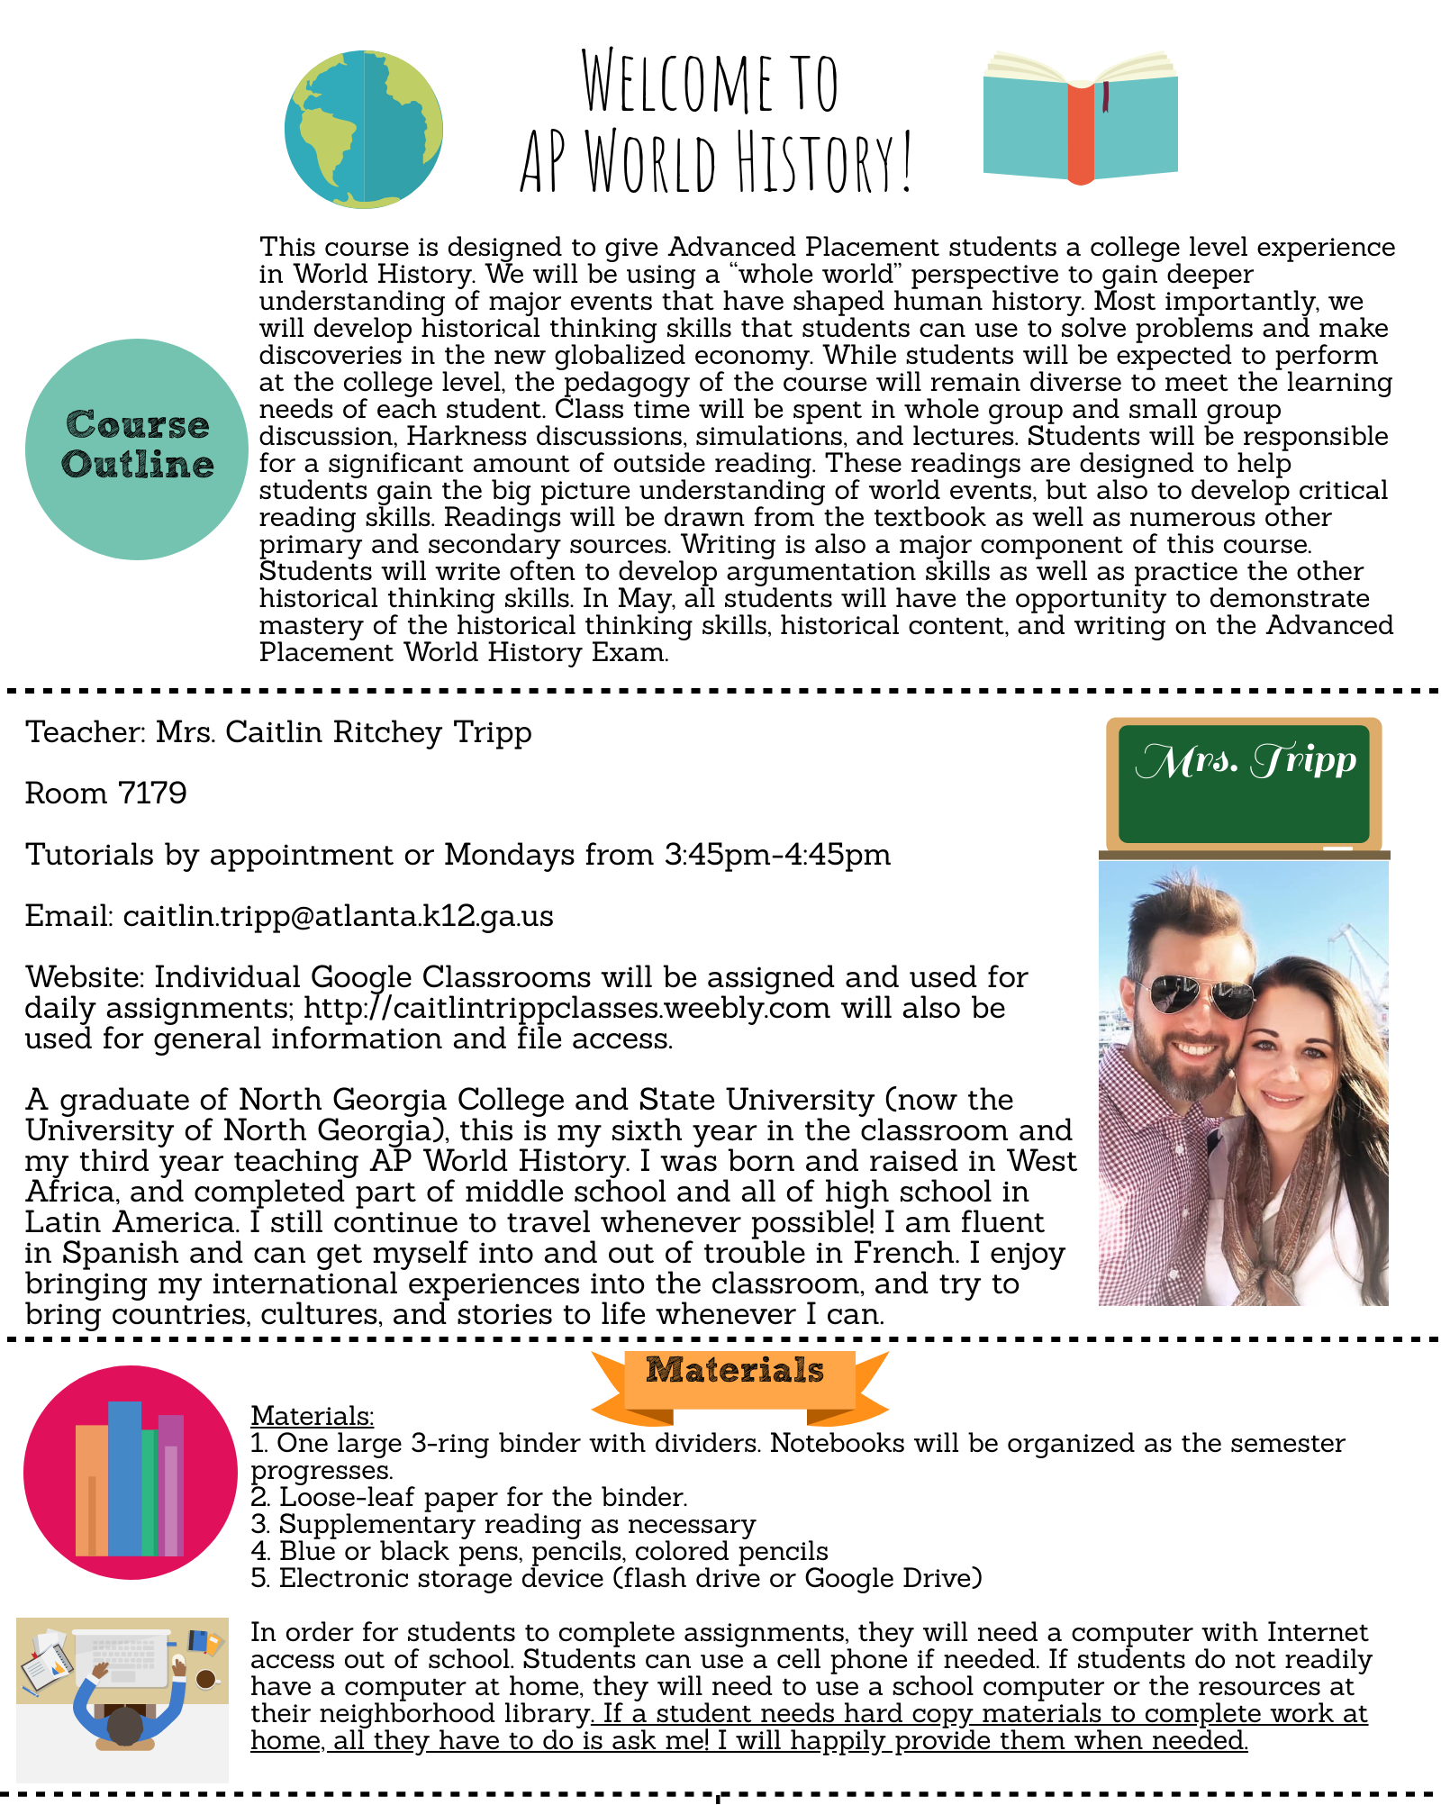
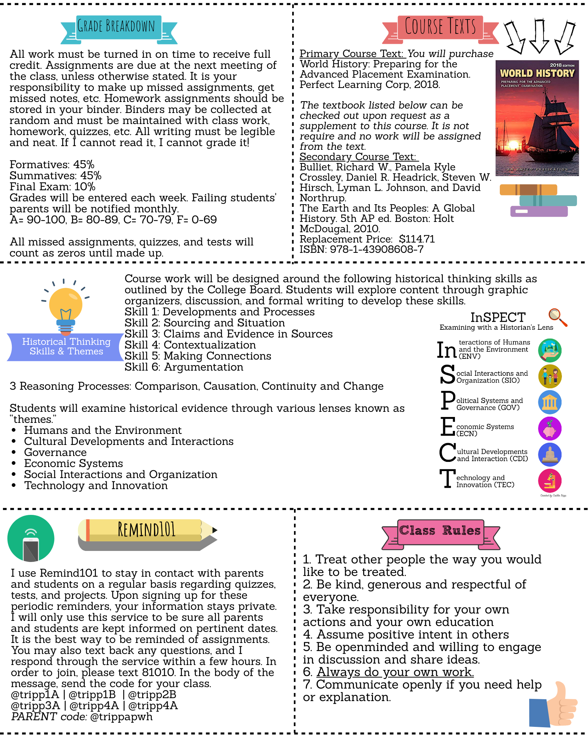

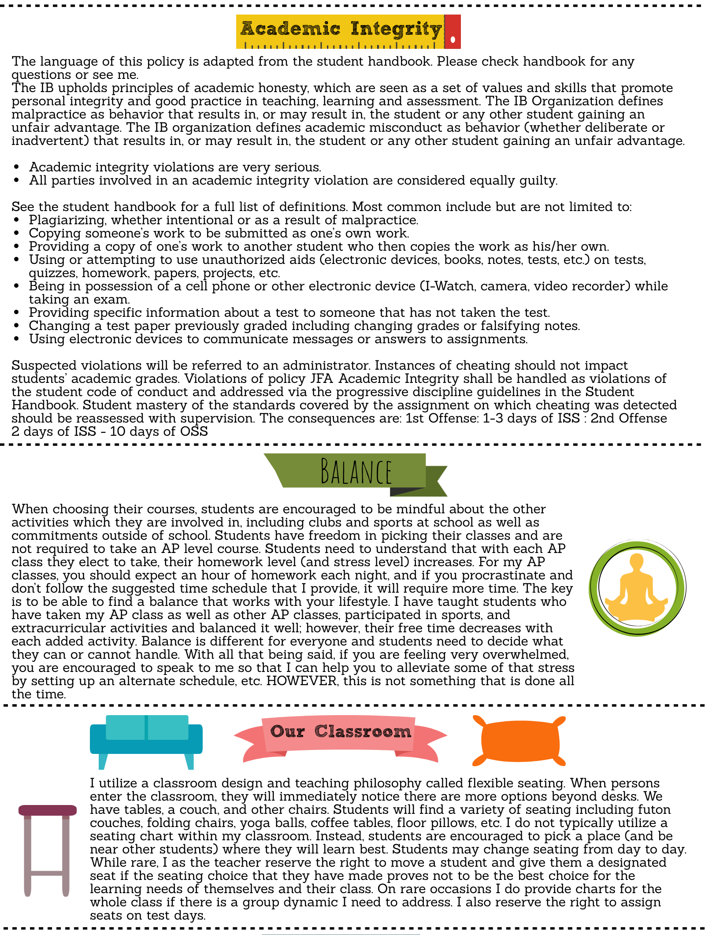
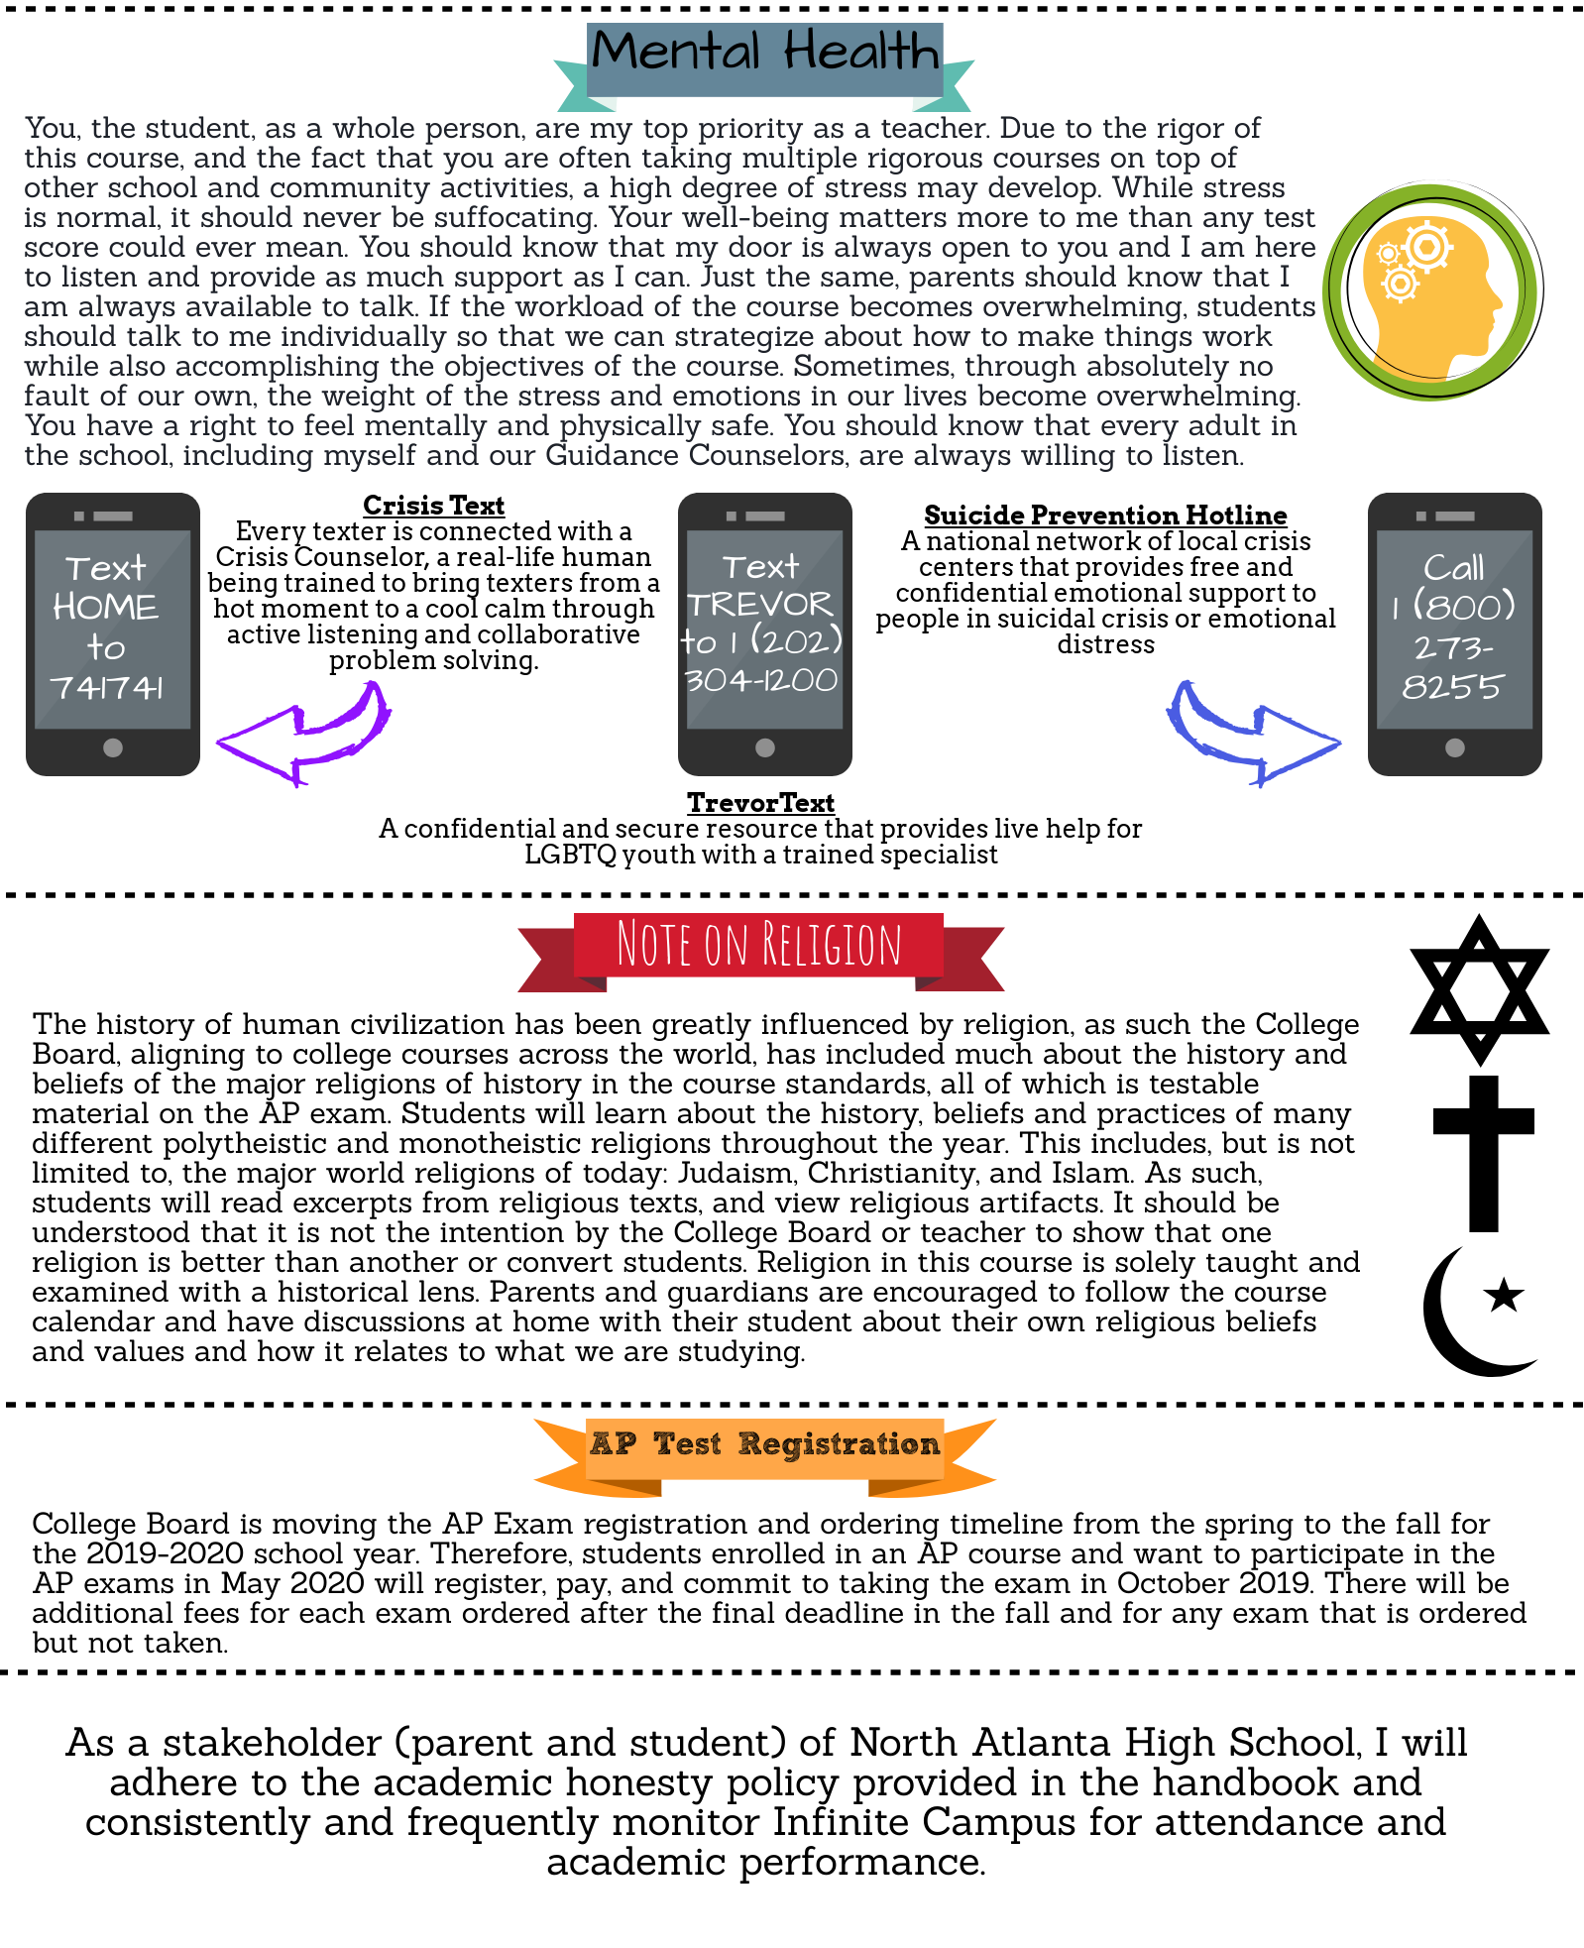
Student-Parent-Teacher Contract
Parents and Students,

After you have read the syllabus (available online at caitlintrippclasses.weebly.com) and discussed it, please take a moment to read each expectation listed below. If you cannot agree to an expectation, please explain why the expectation cannot be fulfilled.

Expectations for the student:

1. Be prepared and on time for every class.
2. Treat classmates and teacher with respect.
3. Demonstrate mature behavior.
4. Actively participate in class.
5. Complete all assignments on time.
6. Faithfully and thoughtfully complete reading assignments.
7. Demonstrate honesty on all assignments.
8. Seek help and participate in tutorials if needed.
9. Accept the consequences of choices.

Expectations for the parent:
1. Monitor student performance using Infinite Campus and by viewing their binder.
2. Ensure student has time and place to read/study every day.
3. Communicate with the teacher about concerns.
4. Help students obtain materials needed for class.

By signing, you agree to the following statement:
“I have read and fully understand the guidelines and policies written here and in the course syllabus for AP World History taught by Mrs. Tripp at North Atlanta HS. As a stakeholder (parent and student) of North Atlanta High School, I will adhere to the academic honesty policy provided in the handbook and consistently and frequently monitor Infinite Campus for attendance and academic performance.”

Please sign and return this contract by August 15, 2019.

_____________________________________ _____________________________________
Parent Signature Date Student Signature Date

_____________________________________ _____________________________________
Parent Name (printed) Student Name (printed)

Parent Contact Information:
Best Contact Number: ___________________________________ (h), (c), or (w)

Email:________________________________________________________________________
In return, as the teacher, I will make every effort to enforce policies fairly, assist students, maintain an open channel of communication for both students and parents, and be available for questions.

