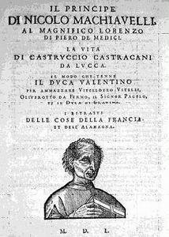
Niccolo Machiavelli: The Prince

Background: One of the most famous political works of the Renaissance era was Niccolo Machiavelli's The Prince, in which he analyzed politics in Renaissance Italy. While more power-hungry rulers embraced Machiavelli's work as legitimizing their methods, many attacked the book because of the ideas he advocated.

Excerpts from The Prince by Niccolo Machiavelli, 1513:

That Which Concerns a Prince on the Subject of the Art of War
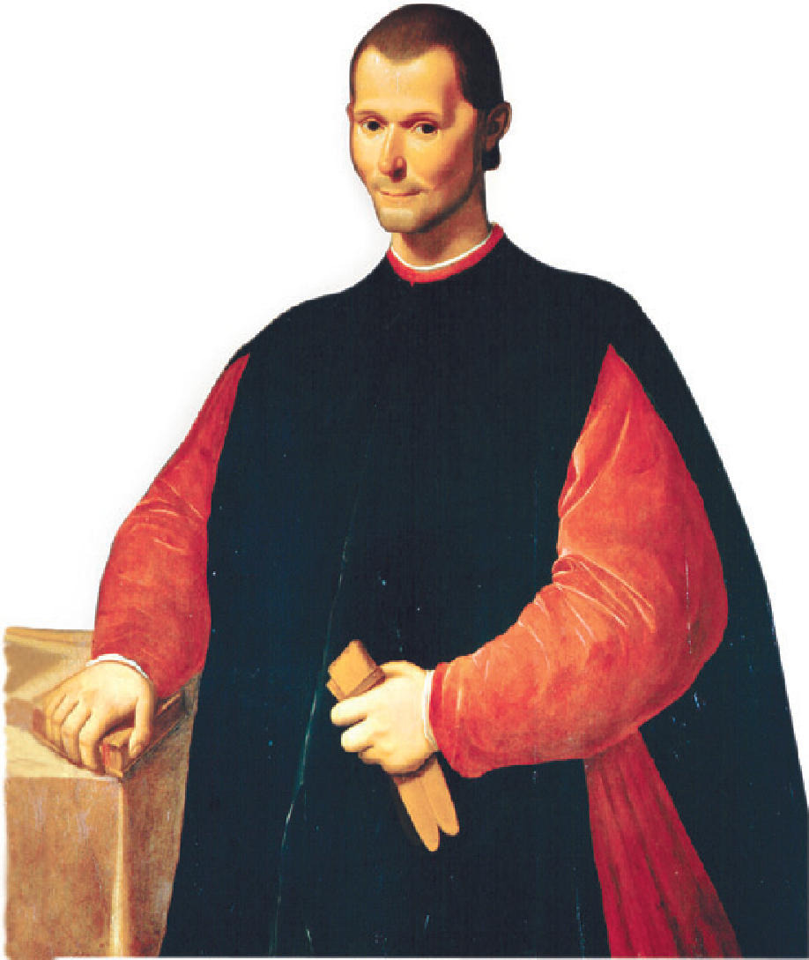
The Prince ought to have no other aim or thought, nor select anything else for his study, than war and its rules and discipline; for this is the sole art that belongs to him who rules, and it is of such force that it not only upholds those who are born princes, but it often enables men to rise from a private station to that rank. And, on the contrary, it is seen that when princes have thought more of ease than of arms they have lost their states. And the first cause of your losing it is to neglect this art; and what enables you to acquire a state is to be master of the art.

Concerning Whether it is Better to be Loved than Feared

Upon this a question arises: whether it is better to be loved than feared or feared than loved? It may be answered that one should wish to be both, but, because it is difficult to unite them in one person, it is much safer to be feared than loved, when, of the two, either must be dispensed with. Because this is to be asserted in general of men, that they are ungrateful, fickle, false, cowardly, covetous, and as long as you successes they are yours entirely; they will offer you their blood, property, life, and children, as is said above, when the need is far distant; but when it approaches they turn against you. …for love is preserved by the link of obligation which, owing to the baseness of men, is broken at every opportunity for their advantage; but fear preserved you by a dread of punishment which never fails. Nevertheless a prince ought to inspire fear in such a way that, if he does not win love, he avoids hatred; because he can endure very well being feared whilst he is not hated, which will always be as long as he abstains from the property of his citizens and subjects and from their women.

Concerning the Way in Which Princes Should Keep Faith
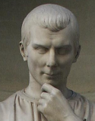
. . . a wise Prince cannot and should not keep his pledge when it is against his interest to do so and when his reasons for making the pledge are no longer operative. If all men were good, this would be a bad precept, but since they are evil and would not keep a pledge to you, then you need not keep yours to them. (The Prince) must stick to the good as long as he can, but, being compelled by necessity, he must be ready to take the way of evil. Therefore it is unnecessary for a prince to have all the good qualities I have enumerated, but it is very necessary to appear to have them. And I shall dare to say this also, that to have them and always to observe them is injurious, and that to appear to have them is useful; to appear merciful, faithful, humane, religious, upright, and to be so, but with a mind so framed that should you require not to be so, you may be able and know how to change to the opposite.

