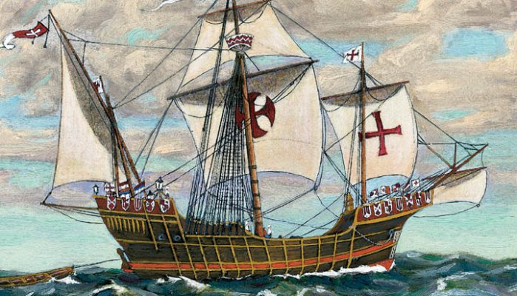
Caravel:
The Caravel was a ship that had many uses. These ships were from small to medium. They could be used as cargo ships, warships, patrol or dispatch boats and also pirate ships. They were mainly used for fishing. The Caravel was from 50 to 200 tons. These ships were cheap and you could get them in shape for working very easily. They were known for their speed and maneuverability. So these ships were used by explorers to explore.
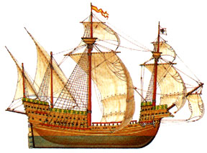
Galleon:
This ship came was developed/came in use during the 16th century. The Galleon was developed from ships such as the Caravel and Carrack. These ships were known for their ability to change during different circumstances. So if you had a Galleon and you were in times of peace you could use it to do trading, fishing, etc. If you were in times of war you could convert it and make it a war ship. These ships had more ribs and bracings which helped them withstand gunfire. So these ships were good because they were fast and could easily convert/change as per the circumstances.

Dutch Ships:
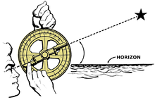
The Dutch Ships helped the Age of Exploration flourish because they became use to explorers. These ships were made so that explorers could explore the Northeast Passage to China and travel with cargo to India. This is how they helped the Age of Exploration flourish.

Astrolabe:
The Astrolabe is an angle and altitude measuring tool. The Astrolabe was first used for astronomy and astrology. It could have been invented by Hipparchus (Greek astronomer and mathematician). It was later used by sailors. The first use at sea was recorded to be in 1481. It was used on a voyage down the African coast by Portuguese explorers. So this tool helped sailors measure the angle of the sun which could then be converted to find latitude. This tool was more accurate at land then at sea.
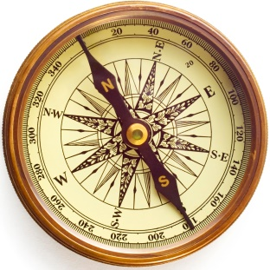
Magnetic Compass and Compass Rose:
The magnetic compass was a compass that had a magnetized needle supporting a magnetic card. This compass showed from four to eight directions. This innovation helped the Age of Exploration flourish because it showed explorers what direction they were headed. So basically it helped explorers reach their destination. The compass rose also told direction.

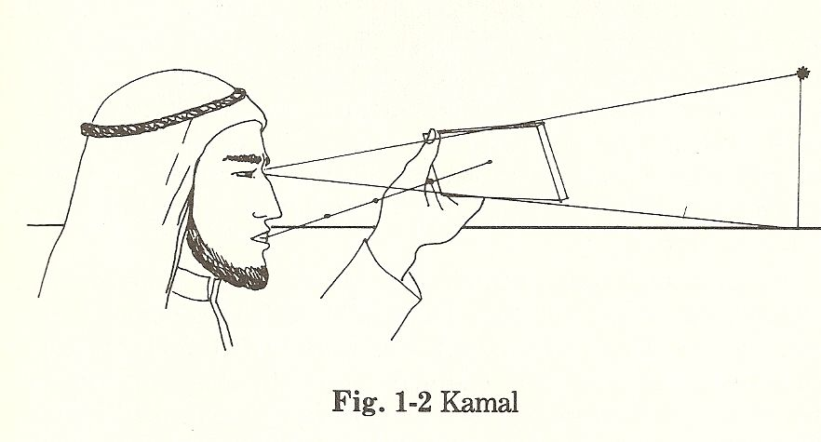
Ka-Mal:
The Ka-Mal was a tool that helped people determine latitude. The Ka-Mal was basically a piece of wood. The person using this tool would sight the horizon at the bottom of this device. They would then sight Polaris at the top of the wood. After everything lined up perfectly the person would know their latitude. This would help people know that they were heading towards the right direction. So the Ka-Mal helped the Age of Exploration flourish because it was a tool that helped people determine latitude. Latitude could help people get a good estimate of about where they were.

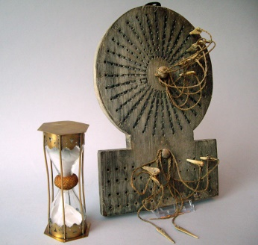
Traverse Board:
The Traverse Board was an important tool because it helped people at sea stay on track. It could also help them stay organized. The Traverse Board was an early version of a computer. It was used in two ways. It helped sailors and explorers record the speed of their ship and the direction it was traveling for the past half hour. So this tool was important because it helped sailors stay on track.

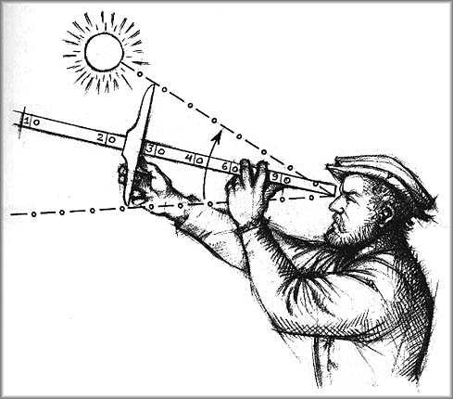
Cross Staff:
The Cross Staff was a tool that was similar to the Ka-Mal. In the Cross Staff the person using it would line up the sun/Polaris on the top of top of the cross bar. The horizon was lined up with the bottom of the cross bar. After everything was perfectly lined up the person using it could read the angular altitude (degrees). This was possible because of a scale that was located on the staff. Then the results could be mathematically converted to tell the latitude of the person using the Cross Staff. So this tool helped the Age of Exploration flourish because it could help someone find latitude. So basically this tool helped explorers and sailors navigate.
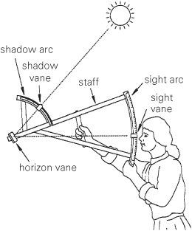
Back Staff:
The Back Staff was a tool similar to the cross staff. It was used to measure the altitude of the sun which could help you find latitude. This device was created because when you used the cross staff you would have to look at the sun which could cause eye problems. If you had the Back Staff you could use the sun's shadow. So the Back Staff helped the Age of Exploration flourish because it could help someone determine latitude which could help you navigate to places.

Lead Line:
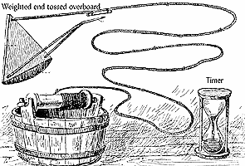
The Lead Line was an important tool because it helped sailors and explorers measure the depth of the ocean. It could also be used to get a sample of the bottom of the ocean. This device was helpful to sailors because it helped them define the type of ocean they were sailing over and how deep the water was. If you wanted a sample of the bottom of the ocean you could put a glob of tallow or animal fat in a hole at the bottom of the lead line. After the lead line touched the bottom of the ocean some things at the bottom would get stuck to the animal fat or tallow. The Lead Line helped the Age of Exploration flourish because it helped sailors and explorers know what type of ocean they were traveling over. If the sailors didn't have the Lead Line they could probably hit something such as a reef.

Timekeeping and Navigation:
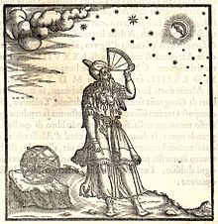
Timekeeping and Navigation played a large part in helping the Age of Exploration flourish. Navigation was important because sailors needed longitude and latitude to travel exactly to the destination they wanted to travel. Without longitude and latitude people wouldn't be able to determine location. Timekeeping was important because it helped people keep time and plan better. It helped sailors know when it was time for their duty and it also helped determine how fast the ship was going during a certain amount of time. Many instruments such as the sand glass were used to help keep time.

Quadrant:
The Quadrant was a tool that was used to measure the height of the Polaris (also known as the pole star. The height of Polaris above the horizon changed every time the latitude of the person using the Quadrant changed. So this tool helped determine latitude. Latitude was used for navigation purposes. So this is how the Quadrant helped the Age of Exploration flourish.

