Name:

Include lifespan for each person | 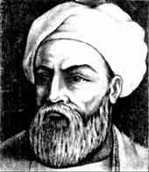  Ibn Battuta  ______ - ______ | 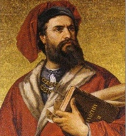  Marco Polo  ______ - ______ | 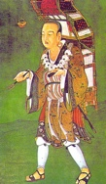  Xuanzang  ______ - ______ | 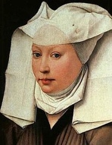  Margery Kempe  ______ - ______
Home/Country of Origin
Dates of Travel
Religion
Purpose of Travel
Significance – why is he or she important?
Use color markers/colored pencils to trace their travel routes. You will need 4 different colors – 1 per person.

Ibn Battuta
Marco Polo
Xuanzang
Margery Kempe

